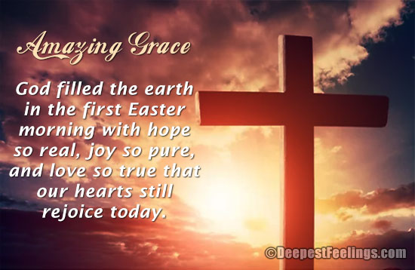
Holy Cross Lutheran Church
Renault, Illinois 62279
Phone (618) 458-6680

Rev. James J. Stefanic, Pastor
Wendy Mueller, Organist 6:30 am
Wayne Johanning, Organist 10:00 a.m.
Easter Sunrise Service April 5th, 2026
Preservice Music
Children’s Bell Anthem “Allelu, Allelu, Everybody Sing Allelu”
Hymn Jesus Christ is Risen Today LSB #457
2 Hymns of praise then let us sing, Alleluia!
Unto Christ, our heav’nly king, Alleluia!
Who endured the cross and grave, Alleluia!
Sinners to redeem and save. Alleluia!

1 Jesus Christ is ris’n today, Alleluia!
Our triumphant holy day, Alleluia!
Who did once upon the cross, Alleluia!
Suffer to redeem our loss. Alleluia!

3 But the pains which He endured, Alleluia!
Our salvation have procured; Alleluia!
Now above the sky He’s king, Alleluia!
Where the angels ever sing. Alleluia!
D 4 Sing we to our God above, Alleluia!
Praise eternal as His love; Alleluia!
Praise Him, all ye heav’nly host, Alleluia!
Father, Son, and Holy Ghost. Alleluia!

P In the name of the Father and of the T Son and of the Holy Spirit.
C Amen.

P Beloved in the Lord! Let us draw near with a true heart and confess our sins unto
God our Father, beseeching Him in the name of our Lord Jesus Christ to grant us
forgiveness.

P Our help is in the name of the Lord,
C who made heaven and earth.
P I said, I will confess my transgressions unto the Lord,
C and You forgave the iniquity of my sin.

Silence for reflection on God’s Word and for self-examination.

P O almighty God, merciful Father,
C I, a poor, miserable sinner, confess unto You all my sins and iniquities with which I have ever offended You and justly deserved Your temporal and eternal punishment. But I am heartily sorry for them and sincerely repent of them, and I pray You of Your boundless mercy and for the sake of the holy, innocent, bitter sufferings and death of Your beloved Son, Jesus Christ, to be gracious and merciful to me, a poor, sinful being.

P Upon this your confession, I, by virtue of my office, as a called and ordained servant of the Word, announce the grace of God unto all of you, and in the stead and by the command of my Lord Jesus Christ I forgive you all your sins in the name of the Father and of the T Son and of the Holy Spirit.
C Amen.

Introit Exodus 15: 1, 2a, 6, 13, 17–18; antiphon: v. 1b
¹I will sing to the Lord, for he has triumphed | gloriously;*
the horse and his rider he has thrown in- | to the sea.
²The Lord is my strength | and my song,*
and he has become my sal- | vation.
⁶Your right hand, O Lord, glorious | in power,*
your right hand, O Lord, shatters the | enemy.
¹³You have led in your steadfast love the people whom you | have redeemed;*
you have guided them by your strength to your ho- | ly abode.
¹⁷You will bring them in and plant them on your own | mountain,*
the place, O Lord, which you have made for | your abode,
the sanctuary, O Lord, which your hands have es- | tablished.*
¹⁸The Lord will reign forever and | ever.
Glory be to the Father and | to the Son*
and to the Holy | Spirit;
as it was in the be- | ginning,*
is now, and will be forever. | Amen.
¹I will sing to the Lord, for he has triumphed | gloriously;*
the horse and his rider he has thrown in- | to the sea.
2

Kyrie
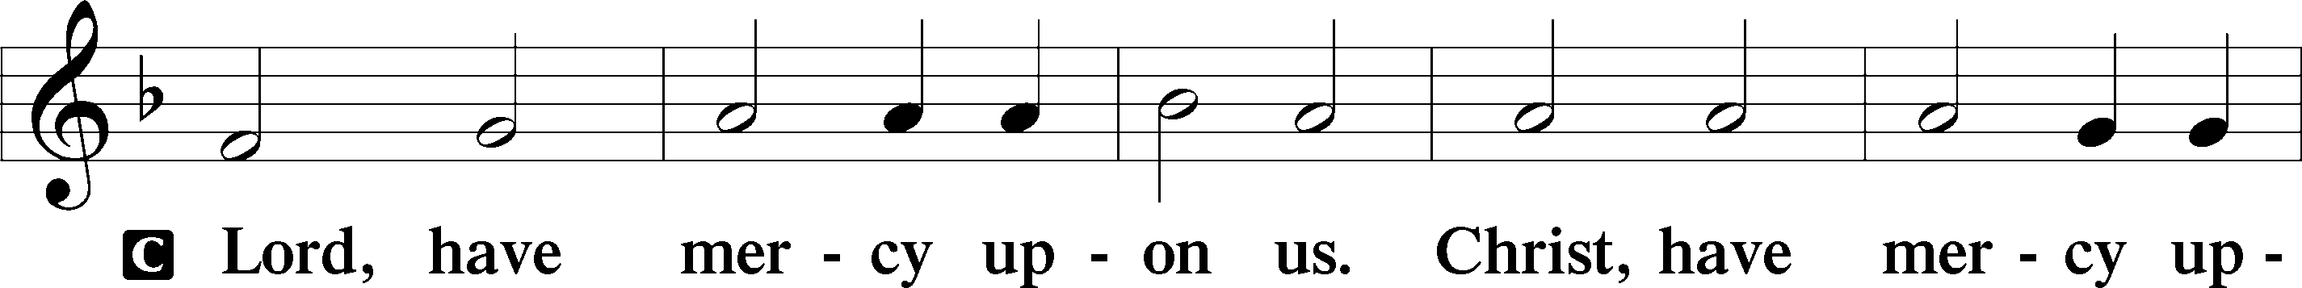
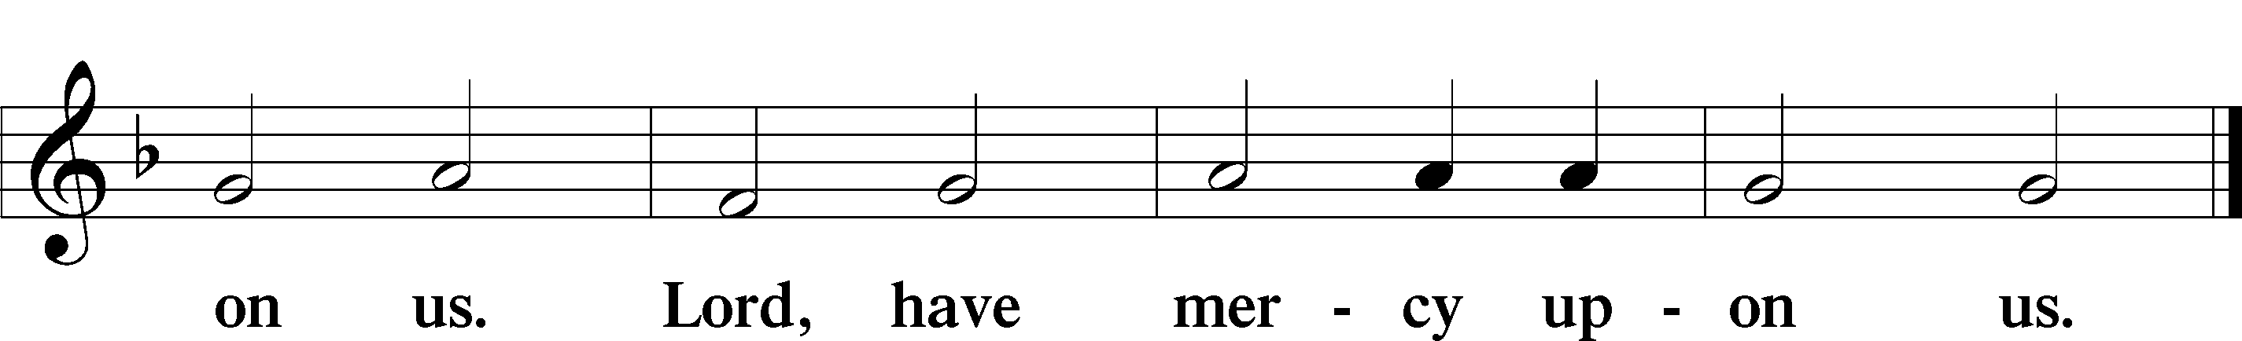

Gloria in Excelsis
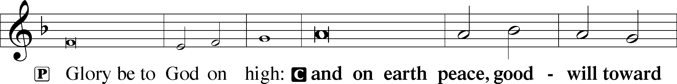
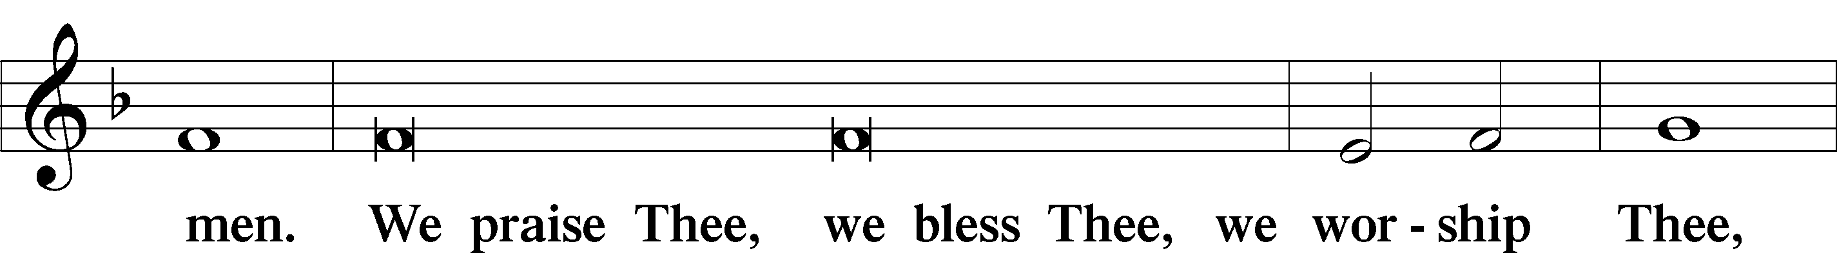
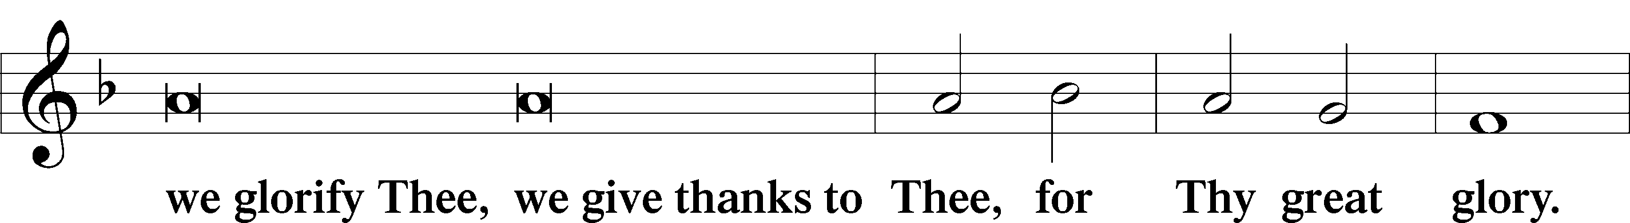
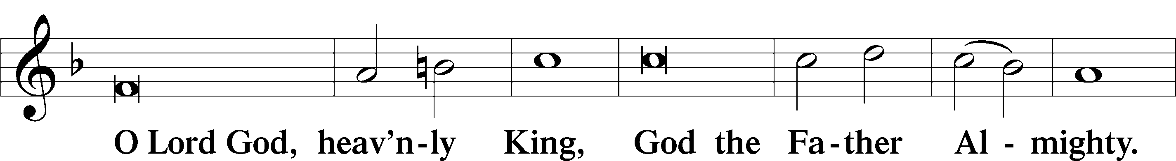
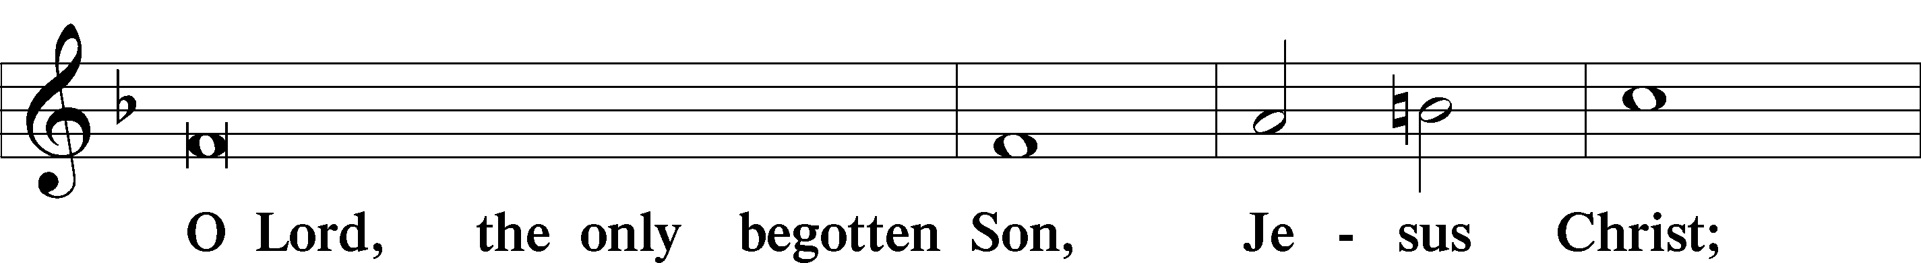
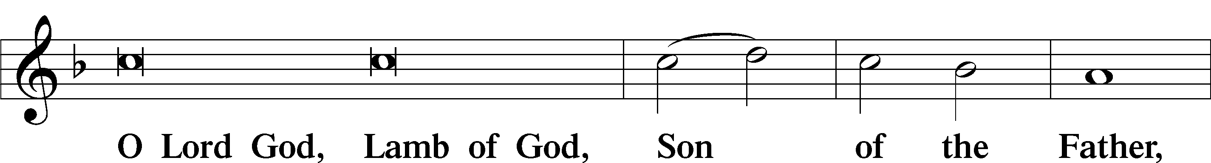
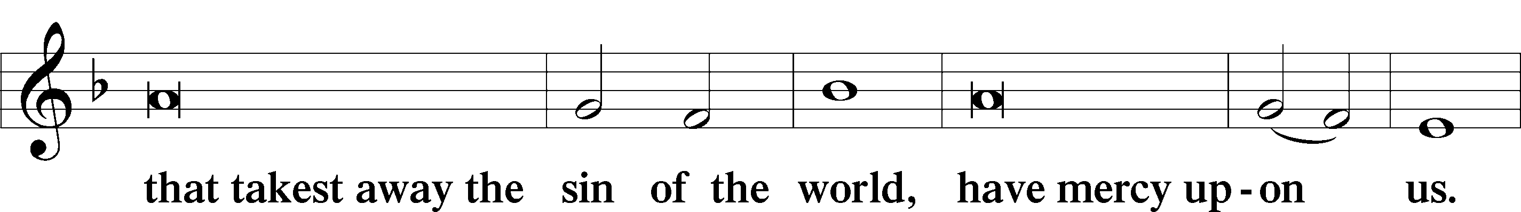
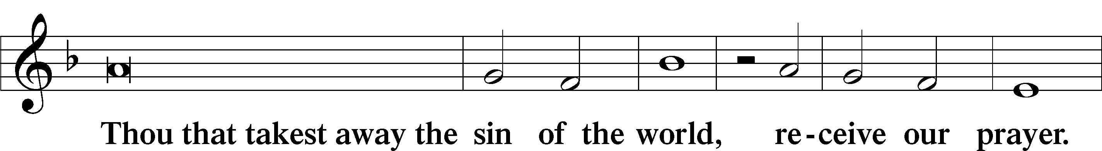
3
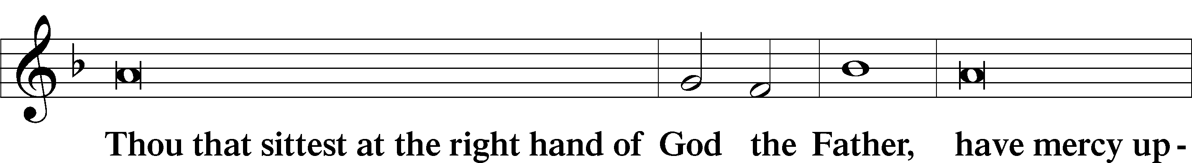
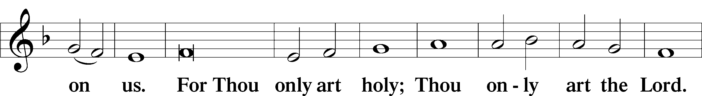
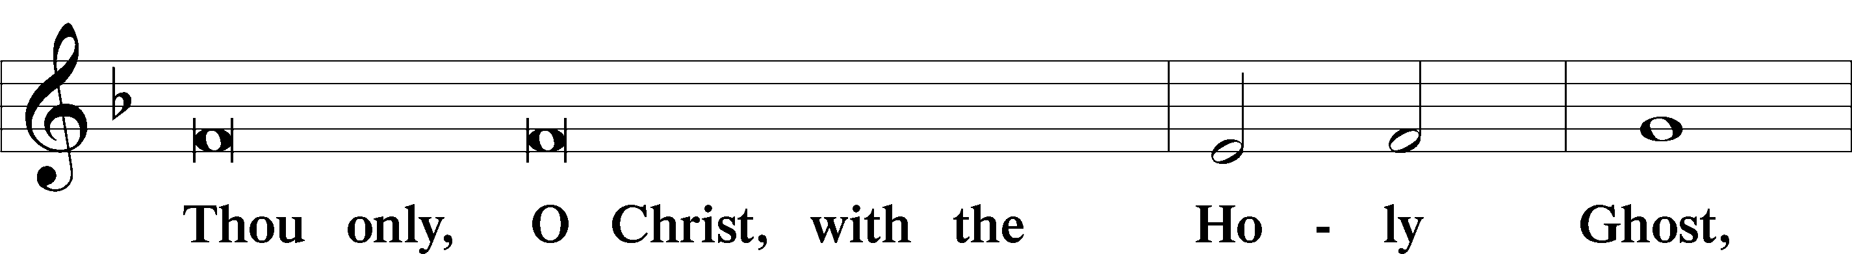
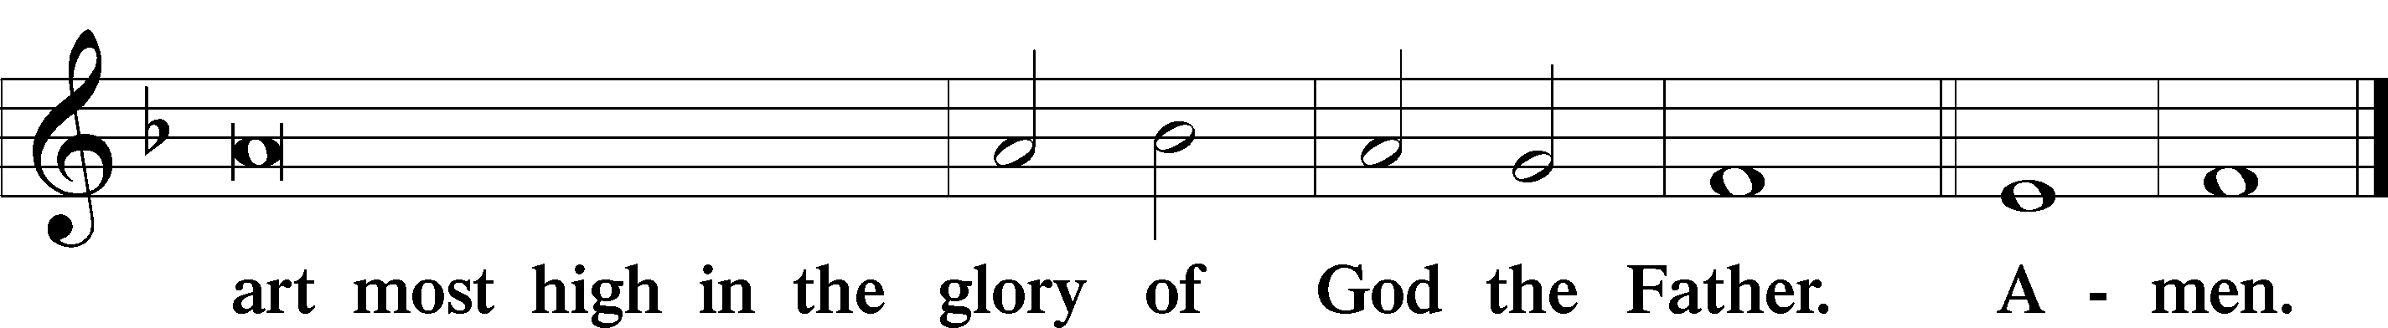

Salutation and Collect of the Day
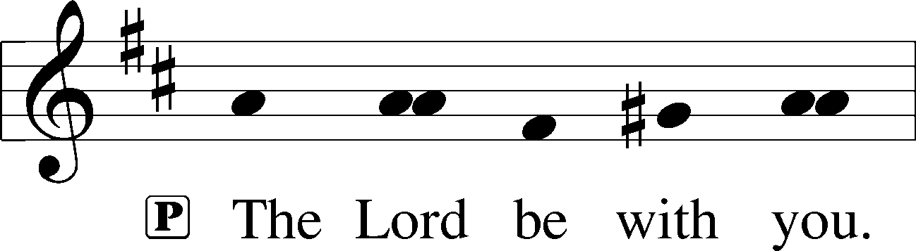

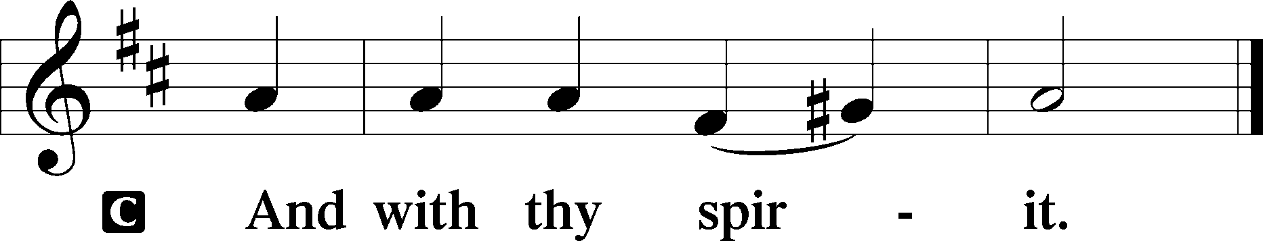

P Let us pray.
Almighty God, through Your only-begotten Son, Jesus Christ, You overcame death and opened to us the gate of everlasting life. We humbly pray that we may live before You in righteousness and purity forever; through the same Jesus Christ, our Lord, who lives and reigns with You and the Holy Spirit, one God, now and forever.
C Amen.

Old Testament Reading Exodus 14:10—15:1
10When Pharaoh drew near, the people of Israel lifted up their eyes, and behold, the Egyptians were marching after them, and they feared greatly. And the people of Israel cried out to the Lord. 11They said to Moses, “Is it because there are no graves in Egypt that you have taken us away to die in the wilderness? What have you done to us in bringing us out of Egypt? 12Is not this what we said to you in Egypt, ‘Leave us alone that we may serve the Egyptians’? For it would have been better for us to serve the Egyptians than to die in the wilderness.” 13And Moses said to the people, “Fear not, stand firm, and see the salvation of the Lord, which he will work for you today. For the Egyptians whom you see today, you shall never see again. 14The Lord will fight for you, and you have only to be silent.”
4
15The Lord said to Moses, “Why do you cry to me? Tell the people of Israel to go forward. 16Lift up your staff, and stretch out your hand over the sea and divide it, that the people of Israel may go through the sea on dry ground. 17And I will harden the hearts of the Egyptians so that they shall go in after them, and I will get glory over Pharaoh and all his host, his chariots, and his horsemen. 18And the Egyptians shall know that I am the Lord, when I have gotten glory over Pharaoh, his chariots, and his horsemen.”
19Then the angel of God who was going before the host of Israel moved and went behind them, and the pillar of cloud moved from before them and stood behind them, 20coming between the host of Egypt and the host of Israel. And there was the cloud and the darkness. And it lit up the night without one coming near the other all night.
21Then Moses stretched out his hand over the sea, and the Lord drove the sea back by a strong east wind all night and made the sea dry land, and the waters were divided. 22And the people of Israel went into sea on dry ground, the waters being a wall to them on their right hand and on their left. 23The Egyptians pursued and went in after them into the midst of the sea, all Pharaoh’s horses, his chariots, and his horsemen. 24And in the morning watch the Lord in the pillar of fire and of cloud looked down on the Egyptian forces and threw the Egyptian forces into a panic, 25clogging their chariot wheels so that they drove heavily. And the Egyptians said, “Let us flee from before Israel, for the Lord fights for them against the Egyptians.”
26Then the Lord said to Moses, “Stretch out your hand over the sea, that the water may come back upon the Egyptians, upon their chariots, and upon their horsemen.” 27So Moses stretched out his hand over the sea, and the sea returned to its normal course when the morning appeared. And as the Egyptians fled into it, the Lord threw the Egyptians into the midst of the sea. 28The waters returned and covered the chariots and the horsemen; of all the host of Pharaoh that had followed them into the sea, not one of them remained. 29But the people of Israel walked on dry ground through the sea, the waters being a wall to them on their right hand and on their left.
30Thus the Lord saved Israel that day from the hand of the Egyptians, and Israel saw the Egyptians dead on the seashore. 31Israel saw the great power that the Lord used against the Egyptians, so the people feared the Lord, and they believed in the Lord and in his servant Moses.
1Then Moses and the people of Israel sang this song to the Lord, saying,
5
“I will sing to the Lord, for he has triumphed gloriously;
the horse and his rider he has thrown into the sea.”
P This is the Word of the Lord.
C Thanks be to God.

Hymn He Is Arisen! Glorious Word LSB #488
He is arisen! Glorious Word!
Now reconciled is God, my Lord;
The gates of heav’n are open.
My Jesus did triumphant die,
And Satan’s arrows broken lie,
Destroyed hell’s fiercest weapon.
O hear what cheer!
Christ victorious, Rising glorious,
Life is giving.
He was dead but now is living!

Epistle 1 Corinthians 15:1–11
1Now I would remind you, brothers, of the gospel I preached to you, which you received, in which you stand, 2and by which you are being saved, if you hold fast to the word I preached to you—unless you believed in vain.
3For I delivered to you as of first importance what I also received: that Christ died for our sins in accordance with the Scriptures, 4that he was buried, that he was raised on the third day in accordance with the Scriptures, 5and that he appeared to Cephas, then to the twelve. 6Then he appeared to more than five hundred brothers at one time, most of whom are still alive, though some have fallen asleep. 7Then he appeared to James, then to all the apostles. 8Last of all, as to one untimely born, he appeared also to me. 9For I am the least of the apostles, unworthy to be called an apostle, because I persecuted the church of God. 10But by the grace of God I am what I am, and his grace toward me was not in vain. On the contrary, I worked harder than any of them, though it was not I, but the grace of God that is with me. 11Whether then it was I or they, so we preach and so you believed.
5

P This is the Word of the Lord.
C Thanks be to God.

Please walk in. The service continues inside.
6
Alleluia
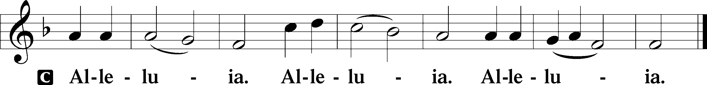

Holy Gospel John 20:1–18
P The Holy Gospel according to St. John, the twentieth chapter.
C Glory be to Thee, O Lord.

1Now on the first day of the week Mary Magdalene came to the tomb early, while it was still dark, and saw that the stone had been taken away from the tomb. 2So she ran and went to Simon Peter and the other disciple, the one whom Jesus loved, and said to them, “They have taken the Lord out of the tomb, and we do not know where they have laid him.” 3So Peter went out with the other disciple, and they were going toward the tomb. 4Both of them were running together, but the other disciple outran Peter and reached the tomb first. 5And stooping to look in, he saw the linen cloths lying there, but he did not go in. 6Then Simon Peter came, following him, and went into the tomb. He saw the linen cloths lying there, 7and the face cloth, which had been on Jesus’ head, not lying with the linen cloths but folded up in a place by itself. 8Then the other disciple, who had reached the tomb first, also went in, and he saw and believed; 9for as yet they did not understand the Scripture, that he must rise from the dead. 10Then the disciples went back to their homes.
11But Mary stood weeping outside the tomb, and as she wept she stooped to look into the tomb. 12And she saw two angels in white, sitting where the body of Jesus had lain, one at the head and one at the feet. 13They said to her, “Woman, why are you weeping?” She said to them, “They have taken away my Lord, and I do not know where they have laid him.” 14Having said this, she turned around and saw Jesus standing, but she did not know that it was Jesus. 15Jesus said to her, “Woman, why are you weeping? Whom are you seeking?” Supposing him to be the gardener, she said to him, “Sir, if you have carried him away, tell me where you have laid him, and I will take him away.” 16Jesus said to her, “Mary.” She turned and said to him in Aramaic, “Rabboni!” (which means Teacher). 17Jesus said to her, “Do not cling to me, for I have not yet ascended to the Father; but go to my brothers and say to them, ‘I am ascending to my Father and your Father, to my God and your God.’” 18Mary Magdalene went and announced to the disciples, “I have seen the Lord”—and that he had said these things to her.
7

P This is the Gospel of the Lord.
C Praise be to Thee, O Christ.

Nicene Creed
C I believe in one God,
the Father Almighty,
maker of heaven and earth
and of all things visible and invisible.
And in one Lord Jesus Christ,
the only-begotten Son of God,
begotten of His Father before all worlds,
God of God, Light of Light,
very God of very God,
begotten, not made,
being of one substance with the Father,
by whom all things were made;
who for us men and for our salvation came down from heaven
and was incarnate by the Holy Spirit of the virgin Mary
and was made man;
and was crucified also for us under Pontius Pilate.
He suffered and was buried.
And the third day He rose again according to the Scriptures
and ascended into heaven
and sits at the right hand of the Father.
And He will come again with glory to judge both the living and the dead
whose kingdom will have no end.
And I believe in the Holy Spirit,
the Lord and giver of life,
who proceeds from the Father and the Son,
who with the Father and the Son together is worshiped and glorified
who spoke by the prophets.
And I believe in one holy Christian and apostolic Church,
I acknowledge one Baptism for the remission of sins,
and I look for the resurrection of the dead
and the life T of the world to come. Amen.
8

Hymn Awake, My Heart, with Gladness LSB 467 (Hymn of the month)
2 The foe in triumph shouted
When Christ lay in the tomb;
But lo, he now is routed,
His boast is turned to gloom.
For Christ again is free;
In glorious victory
He who is strong to save
Has triumphed o’er the grave.

1 Awake, my heart, with gladness,
See what today is done;
Now, after gloom and sadness,
Comes forth the glorious sun.
My Savior there was laid
Where our bed must be made
When to the realms of light
Our spirit wings its flight.
4 Now hell, its prince, the devil,
Of all their pow’r are shorn;
Now I am safe from evil,
And sin I laugh to scorn.
Grim death with all its might
Cannot my soul affright;
It is a pow’rless form,
Howe’er it rave and storm.

3 This is a sight that gladdens—
What peace it doth impart!
Now nothing ever saddens
The joy within my heart.
No gloom shall ever shake,
No foe shall ever take
The hope which God’s own Son
In love for me has won.

5 The world against me rages,
Its fury I disdain;
Though bitter war it wages,
Its work is all in vain.
My heart from care is free,
No trouble troubles me.
Misfortune now is play,
And night is bright as day.
6 Now I will cling forever
To Christ, my Savior true;
My Lord will leave me never,
Whate’er He passes through.
He rends death’s iron chain;
He breaks through sin and pain;
He shatters hell’s grim thrall;
I follow Him through all.

7 He brings me to the portal
That leads to bliss untold,
Whereon this rhyme immortal
Is found in script of gold:
“Who there My cross has shared
Finds here a crown prepared;
Who there with Me has died
Shall here be glorified.”
9

Sermon

P The peace of God, which passes all understanding, keep your hearts and minds
In Christ Jesus
C Amen.

Please stand
Offertory
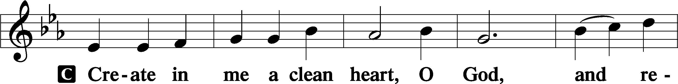
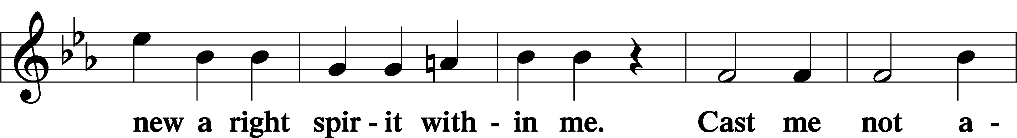
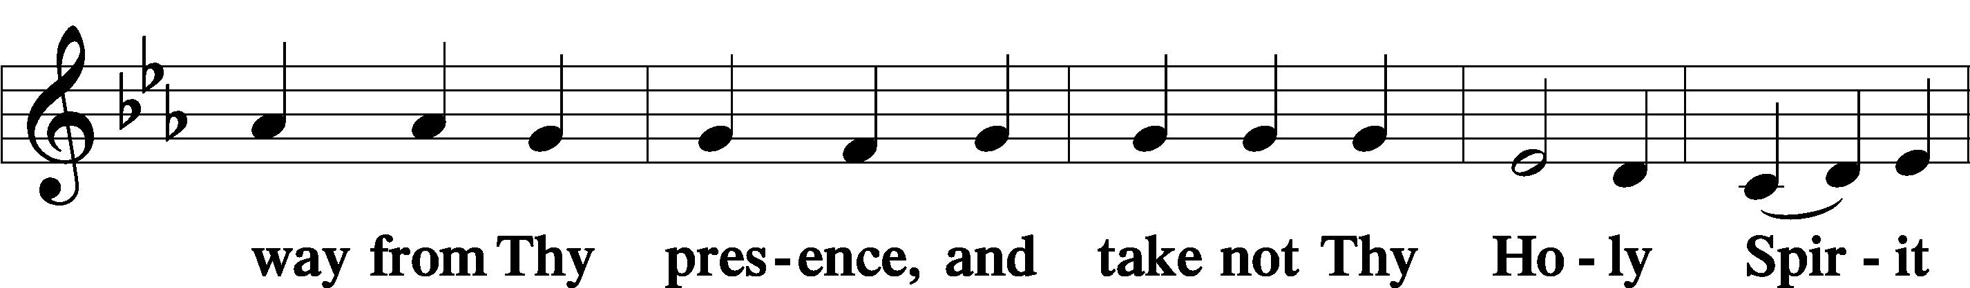
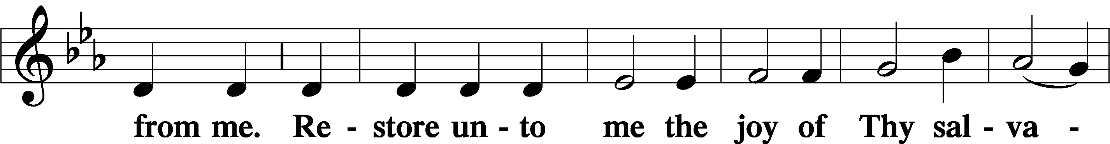
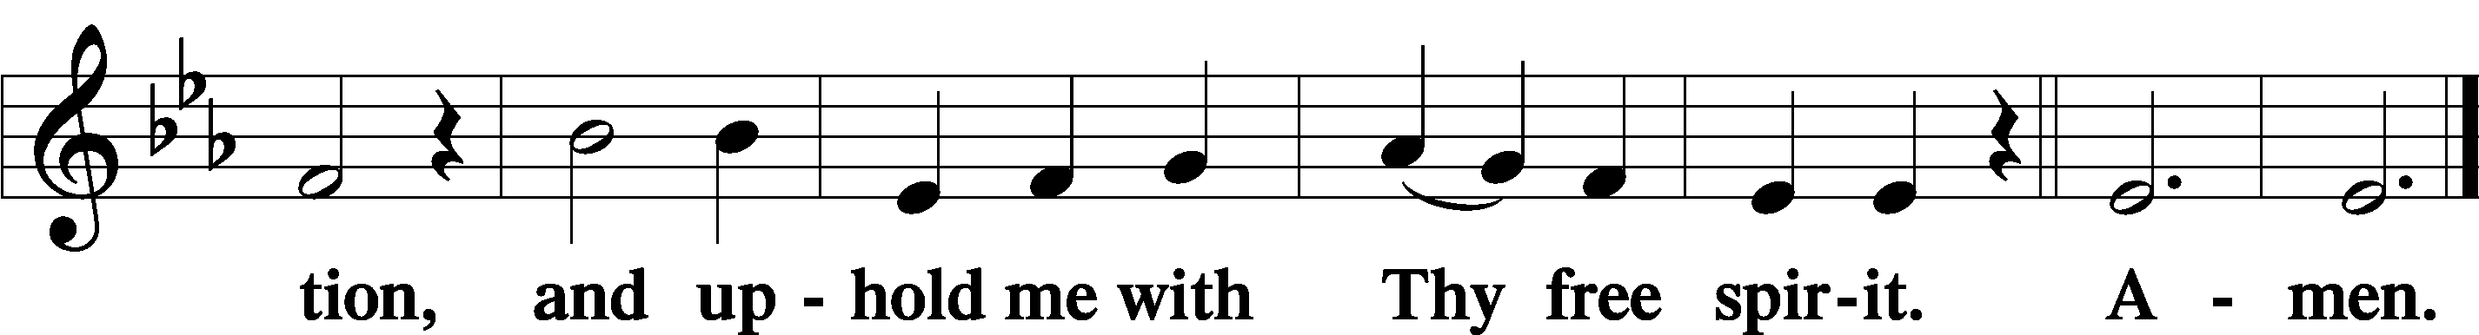

Please sit

Offering

Please stand

Prayer of the Church

10

SERVICE OF THE SACRAMENT
Preface




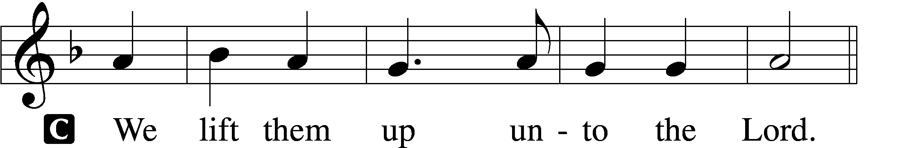

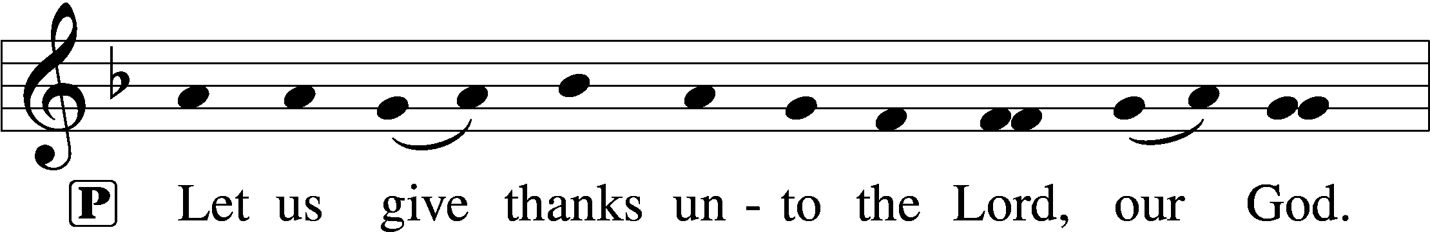
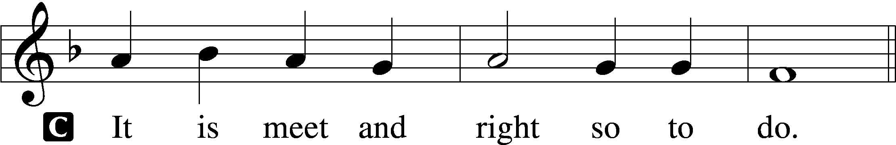

Proper Preface
P It is truly meet, right, and salutary . . . evermore praising You and saying:

Sanctus
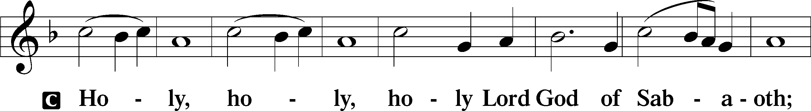
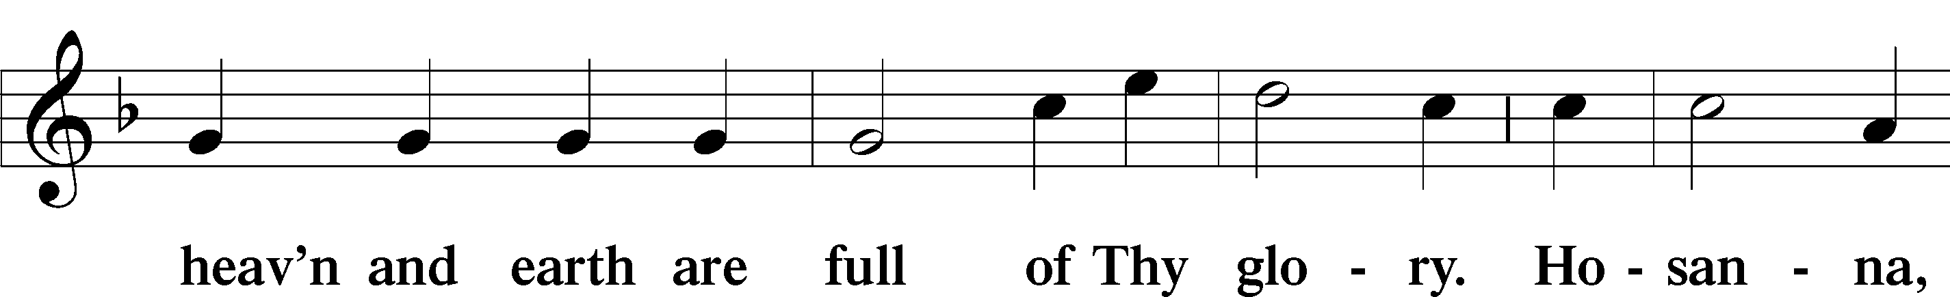
11
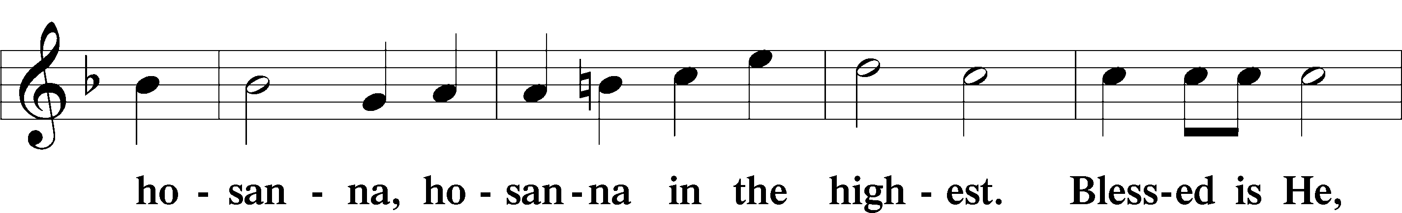
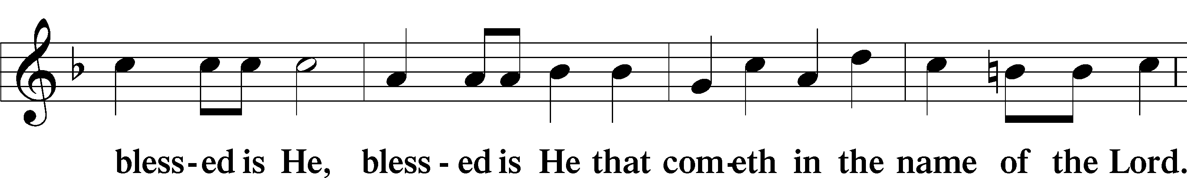
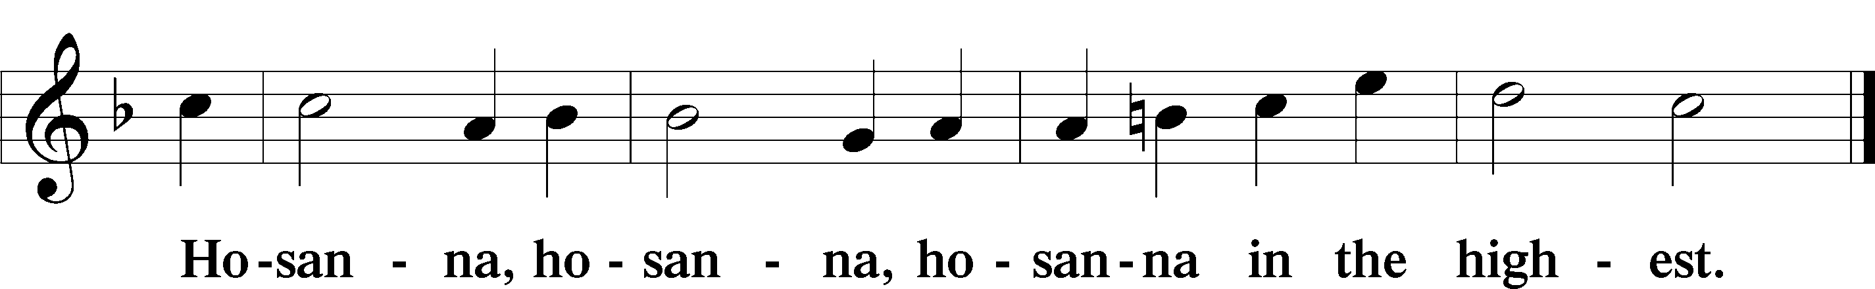

Lord’s Prayer
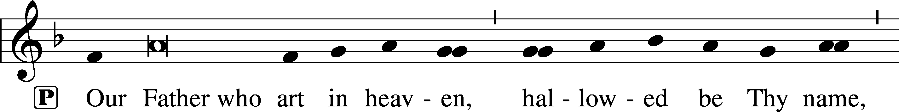
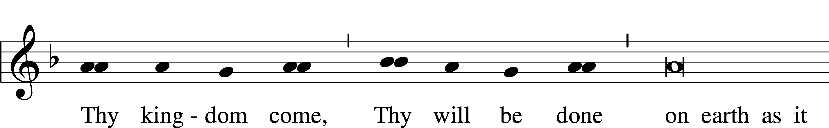
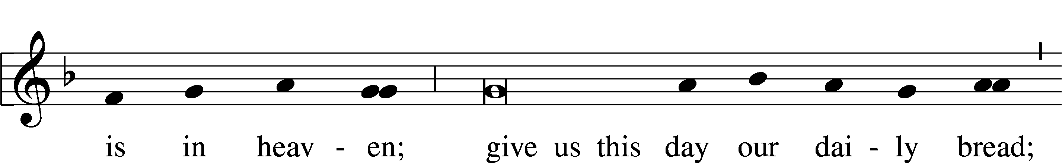
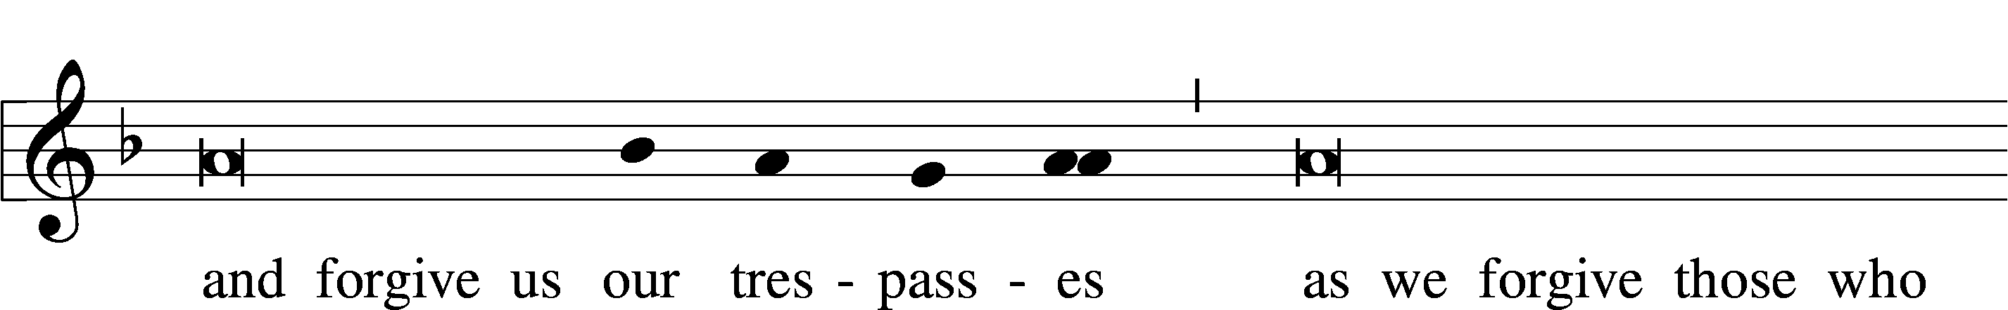
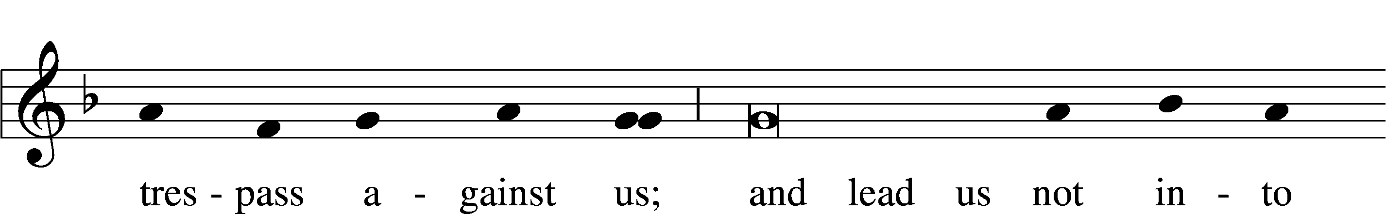
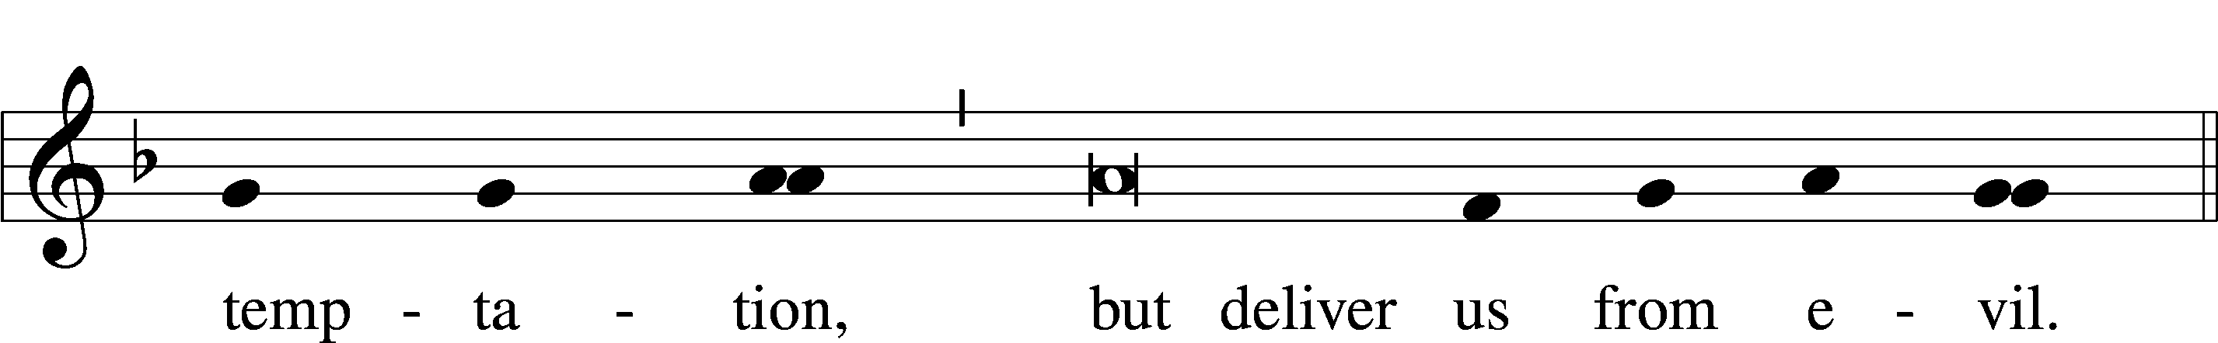
12
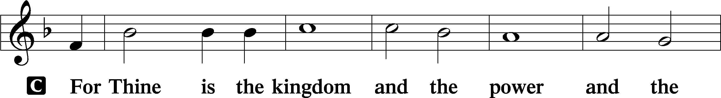
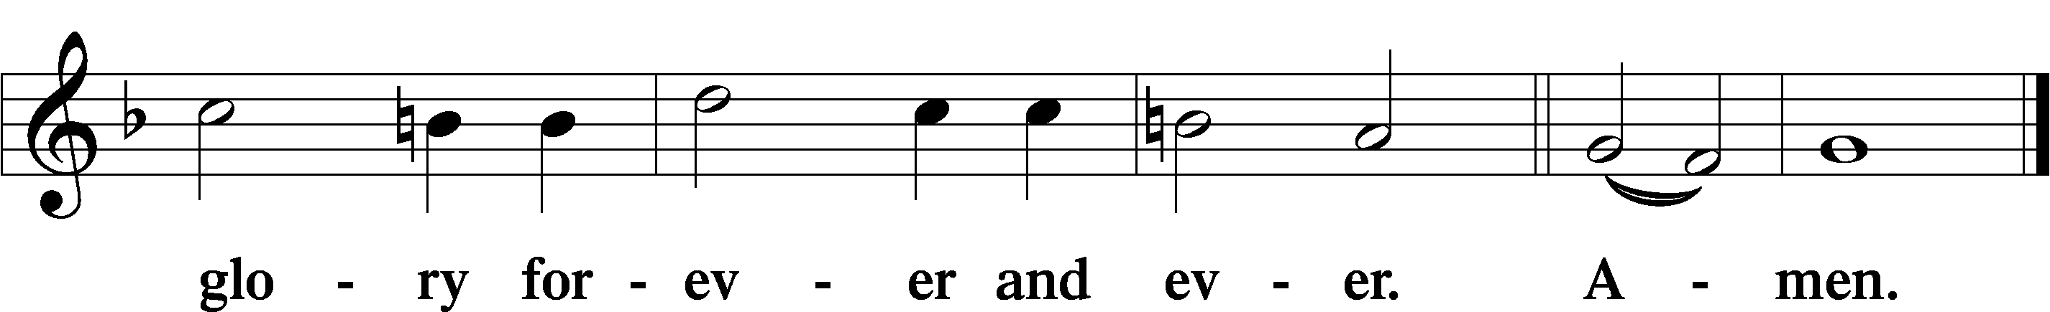

The Words of Our Lord
P Our Lord Jesus Christ, on the night when He was betrayed, took bread,
and when He had given thanks, He broke it and gave it to the disciples
and said: “Take, eat; this is My T body, which is given for you. This do in remembrance of Me.”
In the same way also He took the cup after supper, and when He had given
thanks, He gave it to them, saying: “Drink of it, all of you; this cup is the new testament in My T blood, which is shed for you for the forgiveness of sins.
This do, as often as you drink it, in remembrance of Me.”

Pax Domini
P The peace of the Lord be with you always.
C Amen.

Agnus Dei
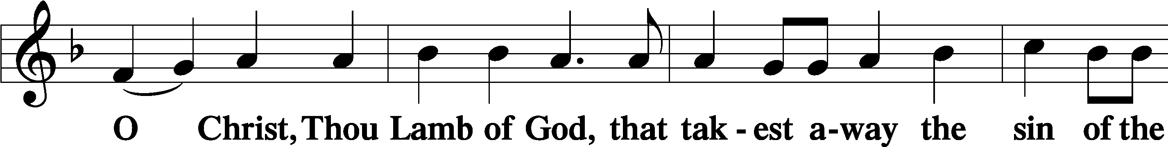
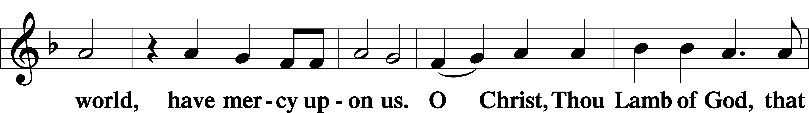
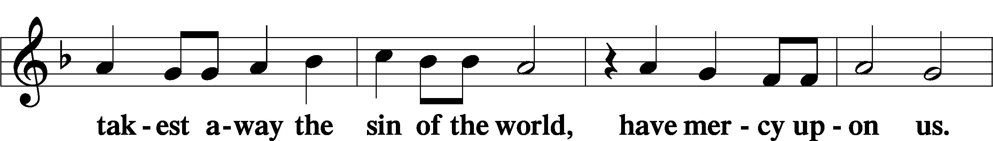
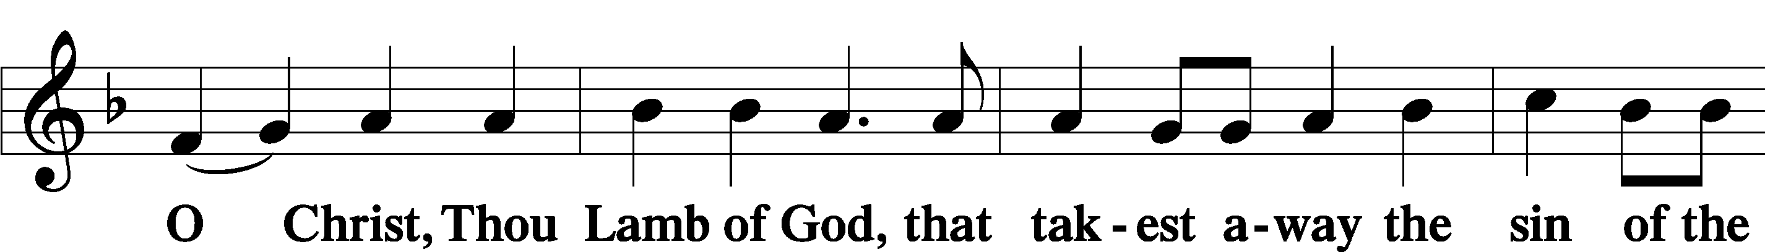
13
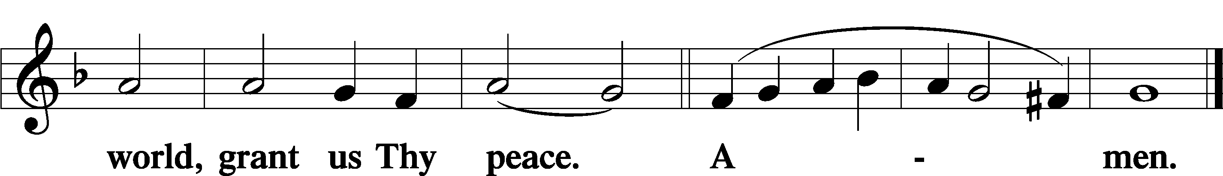

Distribution Hymns:
Solo by Kenny Schultheis Amazing Grace
This Is the Feast LSB pp. 155
I Know That My Redeemer Lives LSB #461
Thanks to Thee, O Christ, Victorious LSB #548
This Joyful Eastertide LSB #482

Please stand
Nunc Dimittis
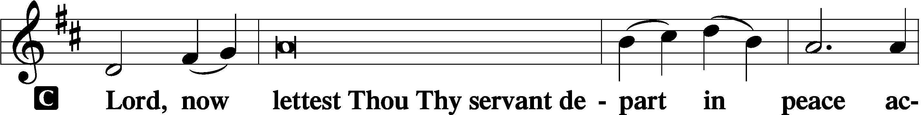

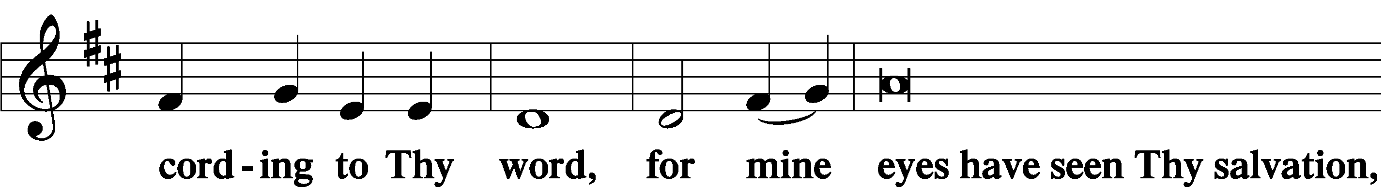

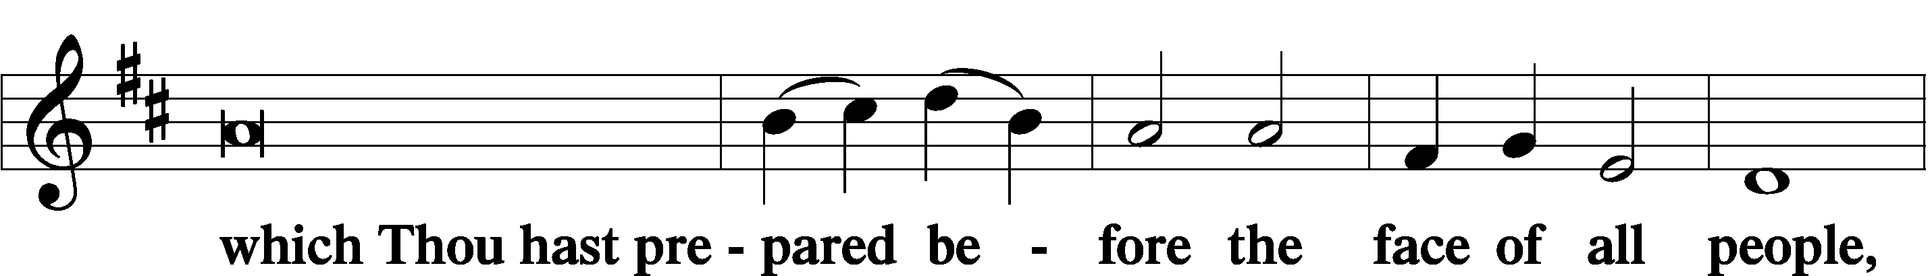

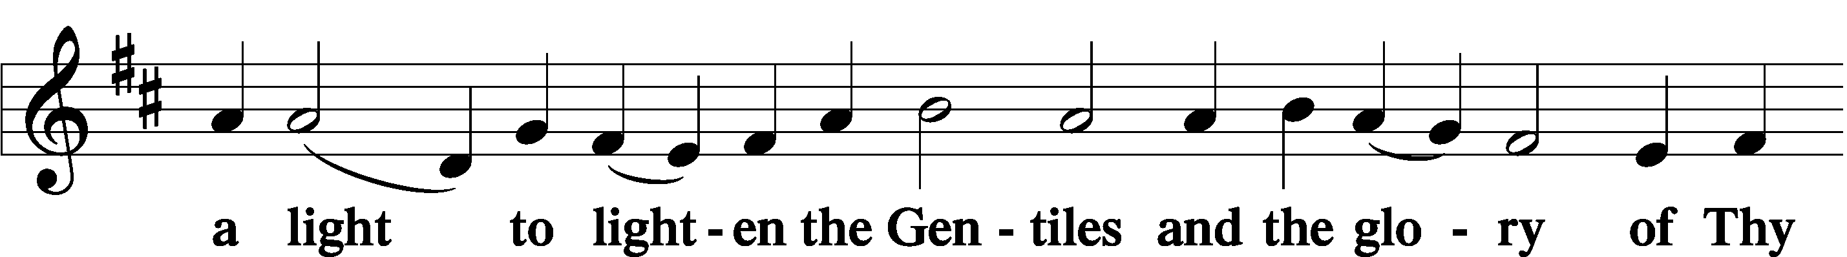

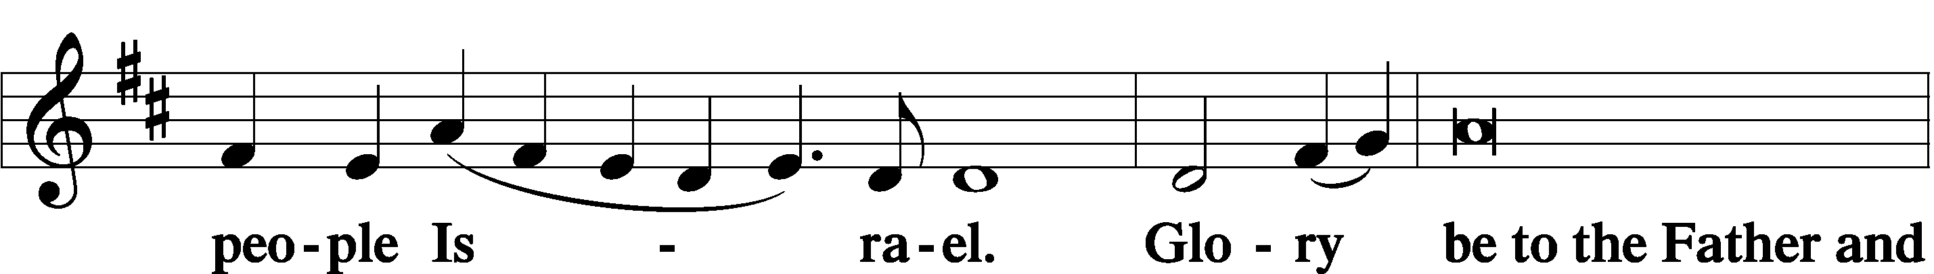
14
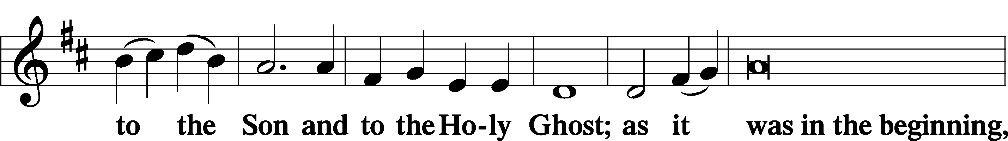

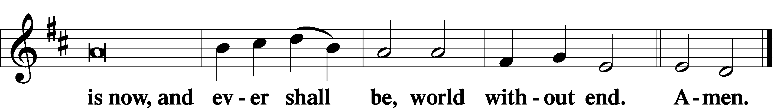

Thanksgiving
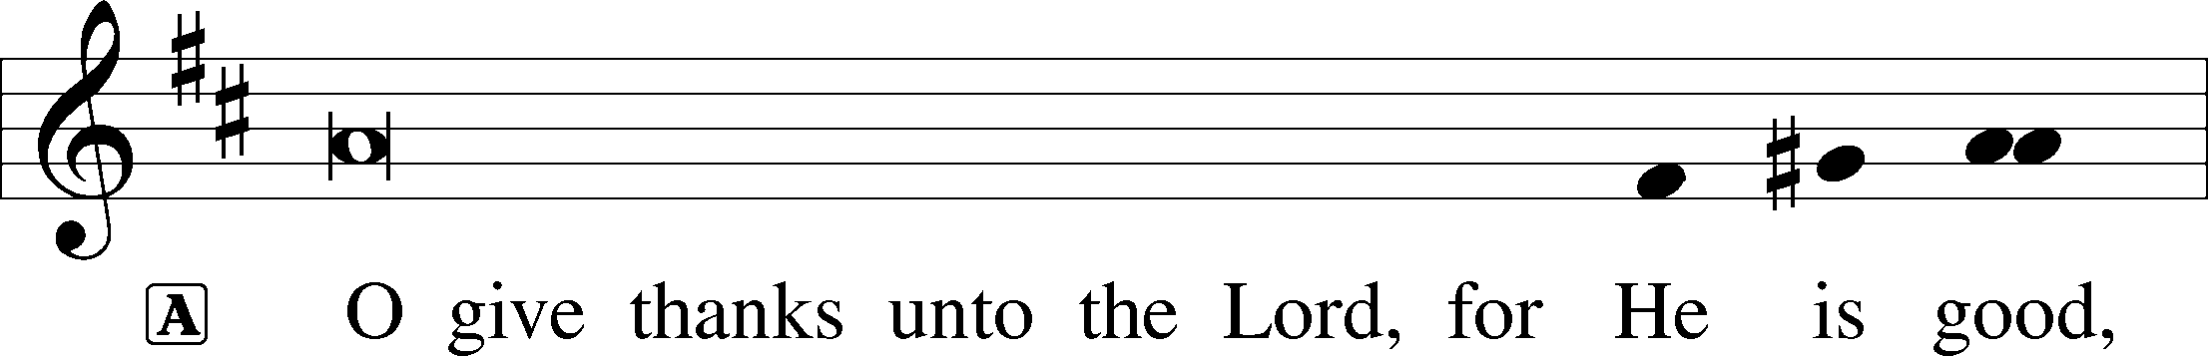

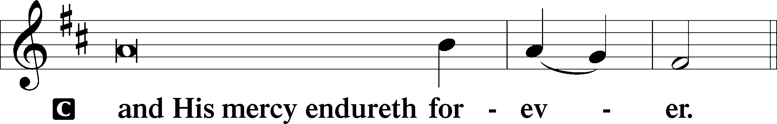

P Let us pray.
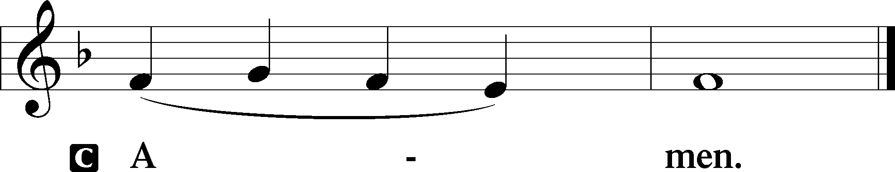

Salutation

Benedicamus
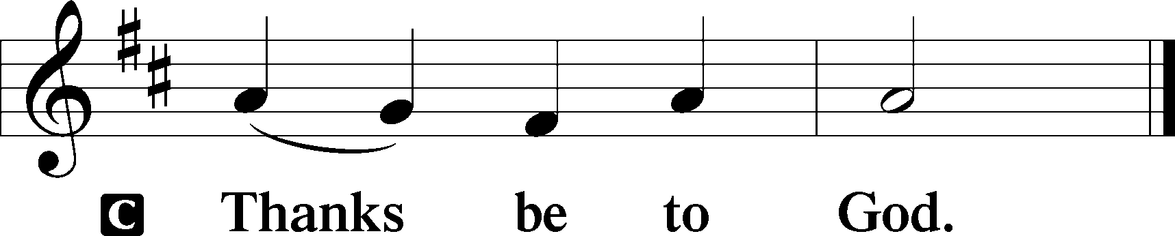
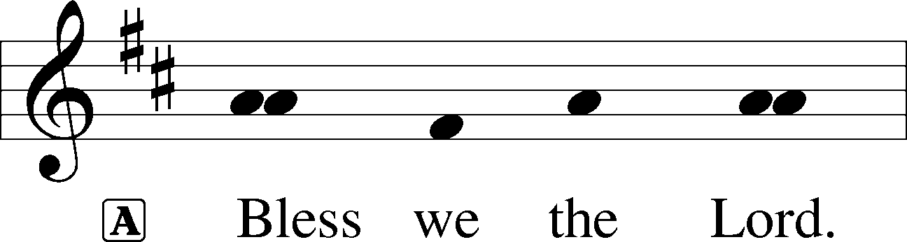

15
Benediction
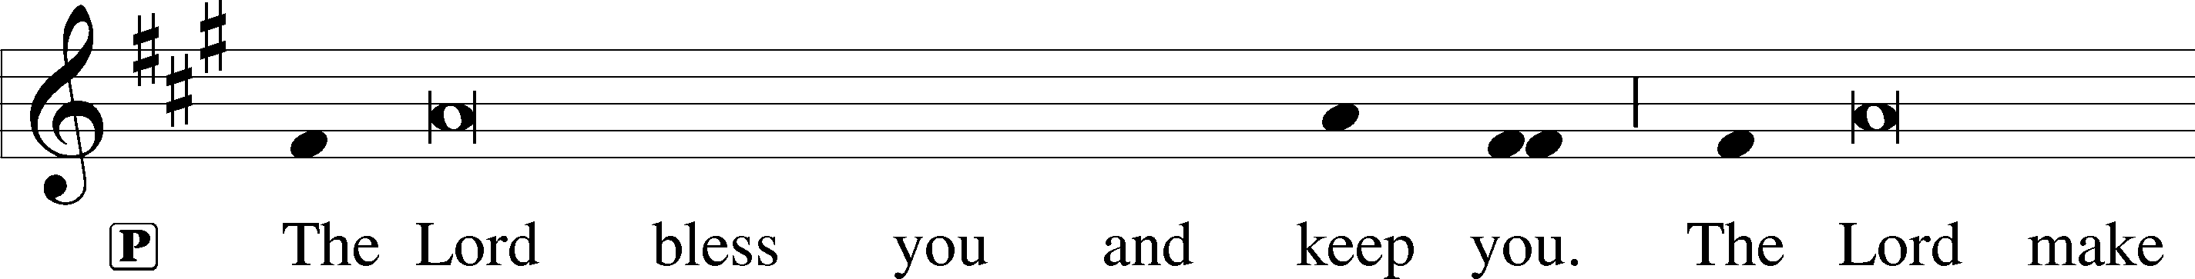
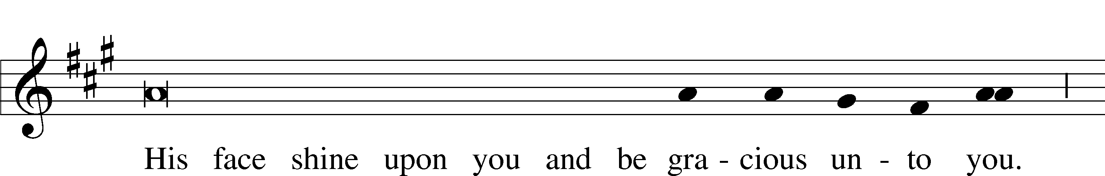
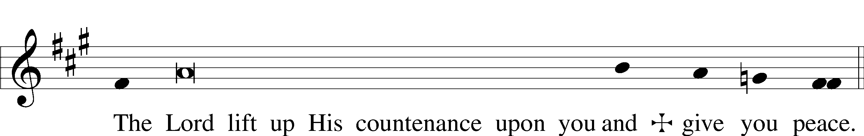

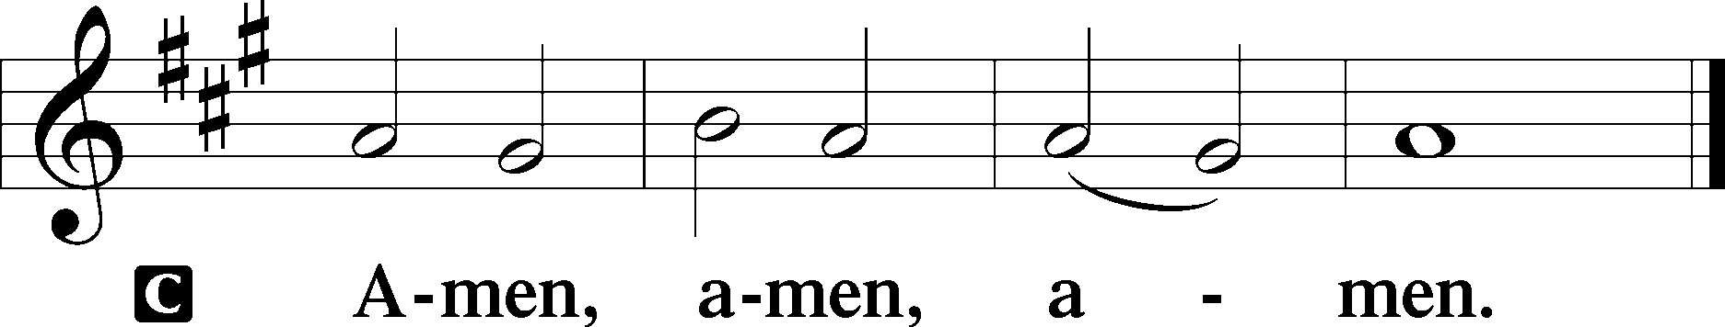

Hymn The Day of Resurrection LSB #478
1 The day of resurrection!
Earth, tell it out abroad,
The passover of gladness,
The passover of God.
From death to life eternal,
From sin’s dominion free,
Our Christ has brought us over
With hymns of victory.
2 Let hearts be purged of evil
That we may see aright
The Lord in rays eternal
Of resurrection light
And, list’ning to His accents,
May hear, so calm and plain,
His own “All hail!” and, hearing,
May raise the victor strain.

D 4 All praise to God the Father,
All praise to God the Son,
All praise to God the Spirit,
Eternal Three in One!
Let all the ransomed number
Fall down before the throne
And honor, pow’r, and glory
Ascribe to God alone!

3 Now let the heav’ns be joyful,
Let earth its song begin,
Let all the world keep triumph
And all that is therein.
Let all things, seen and unseen,
Their notes of gladness blend;
For Christ the Lord has risen,
Our joy that has no end!
16

