
HOLY CROSS VOICE
HOLY CROSS LUTHERAN CHURCH Rev. Royal Boeder, Interim Pastor
2033 Kaskaskia Road Office: 618-458-6680
P.O. Box 7 email: holycros@htc.net
Renault, Illinois 62279

1853 – “Comfort, Comfort, Ye My People” – 2026

Volume XLX, Issue 2 Website: holycrossrenault.org February 2026

A Pastoral Perspective
The Pastor’s Week

I’ve heard it said, usually in jest, “Pastor, you only work one hour a week.” I generally wryly chuckle along with such sentiments. It’s a misguided but not terribly uncommon thought. A few years ago I was in California. A gentleman who was completely unfamiliar with the Church knew I was a pastor and questioned inquisitively: “And you do that full time?” Last year a friend who didn’t belong to a church inquired, “What do you do all week?”
Fair questions. A pastor must be able to give an account for his labors. What does a pastor do outside of Sunday mornings and the occasional services that pop up?
Let’s be clear that the Office of the Holy Ministry was instituted by Jesus for the benefit of His people. Pastor comes to us from the Latin word meaning “shepherd.” The pastor, the undershepherd of the Good Shepherd, Jesus Christ, is called by God to serve His people. St. Peter, inspired by the Holy Spirit, writes to pastors, “Shepherd the flock of God that is among you, exercising oversight, not under compulsion, but willingly, as God would have you; not for shameful gain, but eagerly; not domineering over those in your charge, but being examples to the flock” (1 Peter 5:2-3).
When I was installed as your pastor I made certain promises regarding what I confess about the Bible and what things I will do. One flows from the other. Confession of the faith leads to action.
The first promises of the pastor are about what he believes. I said that I believe and confess the canonical books of the Old and New Testaments to be the inspired Word of God and the only infallible rule of faith and practice. I confessed that the three Ecumenical Creeds are faithful testimonies to the truth of the Holy Scriptures. I confessed that the Book of Concord is in agreement with the one scriptural faith.
That’s the confession. I hold to the Bible, the Creeds, and the Lutheran Confessions. The order matters. The Bible stands above everything else.
And since I promised to believe the canon, creeds, and Confessions it is necessary that I know what they say. A chunk of the pastor’s weeks must be spent reading and studying them. I would argue this means I need to read my Bible and the Lutheran Confessions at least once through every year.

Why? The next promise the pastor makes at his installation gives us the answer. Everything the pastor does is to be in accord with the Bible. All of his preaching and teaching and administration of the Sacraments must be in conformity to the Scriptures and to the Lutheran Confessions. To do that the pastor has to spend time, and ample time, in study.
But there is more. The pastor promises to teach the Christian faith to all ages. He promises to forgive the repentant and never divulge sins confessed to him. He promises to minister to the sick and dying. He promises to admonish and encourage the people of God to a lively confidence in Christ and in holy living. Finally, he promises to live a holy life, study the Scriptures and the Confessions, and be constant in prayer for those under his pastoral care.
Studying, teaching, preaching, praying, admonishing and encouraging, forgiving, and visiting…these duties make up the bulk of the pastor’s week. You can hold me to it. You can check in with me and make sure that I am doing the very things I promised. Keep me accountable. I’ll happily share what I’ve been studying and teaching and who I have been praying for and visiting. I’ll gladly walk through the Scriptures with you and bring you Christ in hours of sickness and distress. The chief work God has given me is to forgive sins. If your conscience is ever troubled, don’t hesitate. Tell me. I will proclaim Christ crucified for you, and I will never tell anyone your sins.
That’s more than an hour’s worth of work. There’s enough there to keep me occupied for a lifetime. It’s time to get after it in this place, and I couldn’t be more excited to do this with you, the blood bought saints of God at Holy Cross.

Peace,
Pastor Stefanic

What’s Inside:
Page 2 Official Acts, Thanks Yous
Page 3 BOCO News; Voters’ Meeting
Page 4 Church Events & Schedules
Page 5 LWML & Pastor’s Installation
Page 6 LYF & Sunday School News
Page 7 VBS & Upcoming Events
Page 8 Ladies Tea & Memento
Page 9 February Calendar

Holy Cross Information
Phone: 618-458-6680 Parsonage Phone: 618-458-7142 Email: holycros@htc.net Website: holycrossrenault.org Facebook: Holy Cross Lutheran Church Renault



Official Acts:


Rev. James Stefanic
Was held on
January 24, 2026
See photos on page 5.




Directory Changes:
Mrs. Mary Veach
Three Springs Lodge
161 Three Springs Road
Chester, IL 62233


Reminder
Information for the
March Voice
is needed by
***February 17 ***



February 18, 2026
7:00 pm

“We love because
He first loved us.”
1 John 4:19



A Special thank you to the members of Holy Cross for all the work that you put into my day of installation. God be praised for each of you!
Pastor Stefanic
* * * * *
Thank you everyone for your kind words, prayers and memorials for mom, grandmother and great grandmother-Joyce Heller. Your kindness and expressions of sympathy were much appreciated.
Don and Donna, Carrie, Greg and Dana, Josie and Kelly
* * * * *
Thank you to Sharon and Jack Bartosik for fixing the Youth room table, light switch in the Secretary office, light switch in the storage closet, etc. Every little detail of improvement adds a lot to the church. Thank you again for your Love for Christ and our church. Holy Cross Family
* * * * *
Thank you to everyone who helped clean the church parking lot and sidewalks after the winter storm. It really was a huge job that was tackle by so many. Thank you again for an amazing accomplishment. Holy Cross Family
* * * * *
THANK YOU!
In the last year I have been very blessed to be able to go to God’s house at Holy Cross Lutheran Church, Renault and gather together with God’s children to receive God’s abundant gifts of forgiveness of sins, reconciliation with God and the knowledge of eternal life with God.
Thank you for allowing me to be a part of your congregation. I have been blessed by your kind words and encouraging support that has been demonstrated in many ways!
I was glad when they said to me,
“Let us go to the house of the Lord!”
(Psalm 122:1)
Rev. Royal Boeder

Holy Cross Women’s Bible Study
and LWML
February 4, 2026 10 a.m. and 7:00 p.m. in the church social hall
“What-Is-Hap-pen-ing?”
on page 18-19 of the Winter 2025 Quarterly.
We go through many trials in our lives. We feel we have gotten over the hump, but it is just a bump in a long road of potholes. Join us to find out where we can go for comfort in the book of Psalms.
Please bring a Bible.
Note: Mite offerings for mission projects will be
Collected each month we meet.
All women of the congregation and their guests


are welcomed and encouraged to attend.

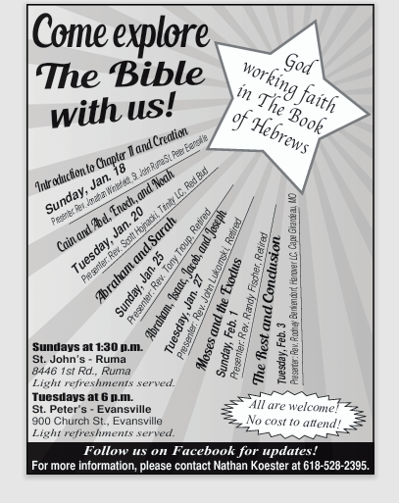



Board of Community Outreach
(By Sharon Bartosik)

Friendship Sunday
Is February 15!

As members of Christ, we should always keep in mind to invite people to come worship with us. The Board of Community Outreach would like to see aside February 15 as Friendship Sunday where we encourage all our members to invite a friend to worship with us that day.

Looking forward to seeing new faces
worshiping with us that day!





&
Rescheduled
Due to Weather Conditions
February 2, 2026
7:00 pm

The first voters meeting of 2026 will be a joint meeting with the congregation. All members of the congregation are invited and encouraged to attend this meeting not only for fellowship, but to hear the reports from 2025 and activities for the coming year.

2026 Offering Envelope Boxes
If anyone did not receive envelopes
and would like them, please contact me.
Please don't use previous year's envelopes
as some numbers have changed.
Thanks, Bonnie

Due to the extreme winter weather, the Bible Presentations were canceled for Sunday, January 25, and Tuesday, January 27. These presentations will be rescheduled as follows: Pastor Anthony Troup will present on Sunday, February 8, at St. John's Lutheran, Ruma, at 1:30 pm and Pastor John Lukomski will present on Tuesday, February 10, at St. Peter's Lutheran, Evansville, at 6pm. We hope to see you there!
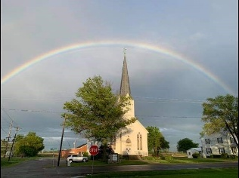

ST. JOHN’S LUTHERAN CHURCH
BALDWIN, IL

All-You-Can-Eat Chicken Dinner
(dine-in only)
March 8, 2026
Serving from 10:30 a.m. – 1:30 p.m.
Carry Outs Available
(1/2 chicken only with sides)
Menu:
Fried Chicken, Mashed Potatoes-Gravy, Corn,
Green Beans, Slaw, Homemade Desserts,
Tea, Lemonade, Coffee
Prices:
Adults - $16 Children - $8 Under 4 – Free

Proceeds to support Lutheran Schools in Red Bud, Prairie, Steeleville and Chester


**Celebrating in FEBRuary**

God’s Blessings to Holy Cross
Birthdays
1 - Eve Stefanic
2 - Amanda Robert
4 - Garrett Braun
6 - Stephanie Siebuhr
6 - Kathy Braun
6 - Aubrey Melching
7 - Don Roth
8 - Betty Gross
8 - Tim Dougherty
9 - Steve Sickmeier
9 - Jessa Johanning
9 - Lilah Johanning
12 - Maverick Veach
15 - Wayne Johanning
15 - Maryann Schrader
17 - Deanna Schultheis
19 - Elizabeth Stefanic
20 - Chrissy Melliere
21 - Jeremiah Kraft
26 - Bonnie Meyer
&
Anniversary

There are not any anniversaries in February.


Scheduled to Serve in February
February 1:
Elder: Leland Mueller
Head Usher: Bill Kunkel
Ushers: Kenny Schultheis, Bob Keller
Aimee Corona, Dwight Jacobs
Acolyte: Jaxon Pigg
Counters: Bill & Sue Kunkel

February 8:
Head Usher: Mark Seboldt
Ushers: Wayne Seders, Bella Corona
Steve Henry, Matt Keller
Acolyte: Cailyn Wilson
Counters: Ginny Strong & Bonnie Meyer

February 15 & 18:
Elder: Mark Seboldt
Head Usher: Jim Seboldt
Ushers: Mark Ottoson, Tim Dougherty
Donald Schultheis, Kyle Guebert
Acolyte: Aubrey Melching
Counters: Kenny & Sandy Schultheis

February 22 & 25:
Head Usher: Don Roth
Ushers: Kenny Schultheis, Bob Keller
Aimee Corona, Dwight Jacobs
Acolyte: John Mark Stefanic
Counters: Bob & Linda Keller

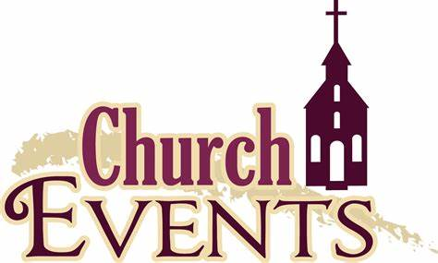

Feb 2: Voters’ Meeting 7:00 pm
Feb 4: Women’s Bible Study 10:00 am & 7:00 pm
Feb 4: Confirmation Class 5:00 pm
Feb 6: Movie Night 7:00 pm
Feb 8: Council Meeting 11:00 am
Feb 9: Media Committee 7:00 pm
Feb 10: Bd of Community Outreach 7:00 pm
Feb 11: Confirmation Class 5:00 pm
Feb 11: SS Teachers & Bd of Ch. Ed 7:30 pm
Feb 12: Garden Place, Oak Hill, Cedarhurst
Feb 15: Friendship Sunday
Feb 15: Ladies “A Chocolate Life Tea” 2 pm – 4 pm
Feb 17: March Voice Deadline
Feb 18: Confirmation Class 5:00 pm
Feb 18: Ash Wednesday Service 7:00 pm
Feb 25: Confirmation Class 5p /Lenten Service 7p
Mar 4: Confirmation Class 5p /Lenten Service 7p
Mar 4: Elders’ Meeting 8:15 pm
Mar 8: Council Meeting 11:00 am
Mar 8: Chicken Dinner St John Baldwin
Mar 11: Confirmation Class 5p /Lenten Service 7p
Mar 13: Wartburg Family Weekend
Mar 18: Confirmation Class 5:00 pm
Mar 18: Lenten Service 7:00 pm
Mar 20: April Voice Deadline
Mar 25: Confirmation Class 5:00 pm
Mar 25: Lenten Service 7:00 pm
Mar 29: Palm/Confirmation Sunday 10:00 am
Apr 2: Maundy Thursday 7:00 pm
Apr 3: Good Friday 7:00 pm
Apr 4: LYF Set up for Easter Breakfast
Apr 5: Easter 6:30 & 10:00 am
Apr 14: Council Meeting 7:00 pm
Apr 18: LWML Spring Retreat
Apr 21: May Voice Deadline
Apr 27: Voters’ Meeting 7:00 pm
Jun 22 – 26: VBS Week



Movie Night
Featuring:
“Cars”
Friday, February 6, 2026
7:00 pm
Holy Cross Social Hall
Snacks & drinks provided
Bring your family and friends!
Lawn chairs, pillows & blankets
are optional.


LWML News and Notes
February 2026
by Linda Keller

- In January we collected $225.00 for Mites at our meeting.
- On February 4, 2006, we will meet in the social hall at 10am and 7pm. Our bible study will be from the Winter Quarterly on page 18-19. The title is “What-Is-Hap-pen-ing?”
We go through many trials in our lives. We feel we have gotten over the hump, but it is just a bump in a long road of potholes. Join us to find out where we can go for comfort in the book of Psalms.
Up Coming Events:
- Southern Illinois Retreat – April 18, 2026 at Our Savior Lutheran Church and Lutheran Student Center in Carbondale, IL, 9:00am-2:30pm. The theme for the day is “See How They Love One Another”. Registrations are due by April 1, 2026 with a cost of $20.00 with includes snacks and lunch.
- SID District Convention—September 11-12, 2026 at Metro East Lutheran High School, Edwardsville, IL. More information to come.
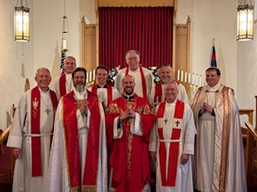
- Mark Your Calendar: On Sunday, February 15, 2026, from 2-4pm, in the Social Hall, our LWML group will be hosting, “A Chocolate Life Tea”. Registration will begin at 1:45 and we will begin our Tea at 2:00. We ask that you bring your favorite tea cup and saucer and join us for a fun filled afternoon. The day will include a Bible Study, Chocolate tasting, yummy desserts and fellowship. We invite the women of the congregation, their family, or guest.

Please keep them in your prayers!
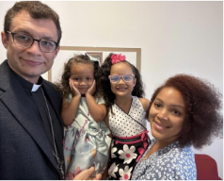
MCMILLERS FROM ROME

Rev Tyler, Yanela, Lia and Alessia McMiller
Italian phone number: +39-346-327-0882
tyler.mcmiller@lcms.org
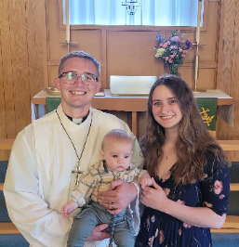
&
THE SEMINARY'S
Michael, Ariann,
and Jude Conroy
conroym@csl.edu

For Pastor James J. Stefanic
On
January 24, 2026
At 3:00 pm
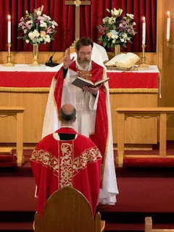

The Meteorologists were not wrong in their prediction of snow for our Renault area. Even though the weather was turning our church grounds white, several of our neighboring Pastors came to install Pastor James J. Stefanic as Holy Cross’ new pastor. We truly appreciate Pastor Heath Curtis, President of the Southern Illinois District; Rev. Peter Ill, Trinity Lutheran Church in Millstadt; Rev. Royal Boeder, Interim Pastor of Holy Cross; Rev. Stephen Krenz, St. Paul’s Lutheran Church in Columbia; Rev. Ralph Laufer, Holy Cross Lutheran Church in Sugar Loaf; Rev. Mike Burdick, St. John’s Lutheran Church, Effingham; Rev. Adam Hiles, Christ Our Savior Lutheran Church, Freeburg; And Rev. Dan Ostlund, Holy Cross Lutheran Church, Wartburg for coming. In attendance there were seventy-two members and neighboring friends welcomed Pastor James Stefanic as the new Pastor of Holy Cross Renault. Everyone enjoyed a delicious meal following in the Social Hall.

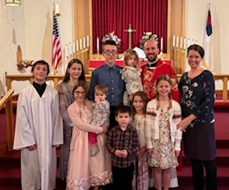
The Stefanic Family
Pastor James Stefanic
Mrs. Sarah Stefanic
John Mark
Elizabeth
Elijah
Hannah
Miriam
Abigail
Joshua
Rebekah and
Eve




(By Jenny Candler)

LYF sponsored a Bingo Afternoon on January 10, 2026. An estimate of forty attendees enjoyed an afternoon of fun and fellowship.
We would like to thank everyone who was able to come and meet the Stefanic family.


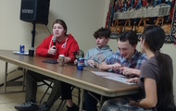

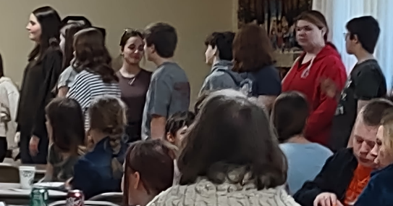

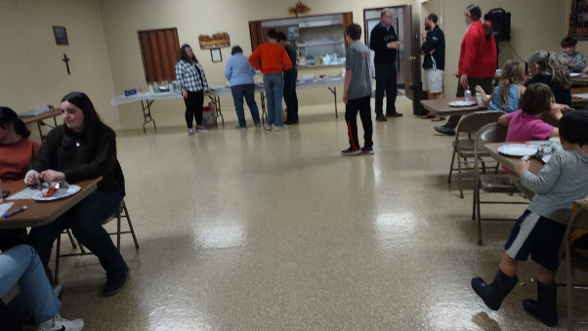
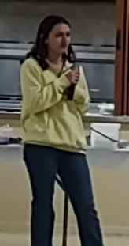

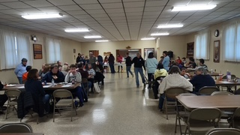

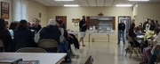


Acolyte February Schedule:
4: Jaxon Pigg
11: Cailyn Wilson
18: Aubrey Melching
25: John Mark Stefanic

Upcoming events:
February 1: our next meeting
February 6: Movie Night
February 15: Friendship Sunday


Sunday School Teachers & Board of
Christian Education Meeting:
February 11 at 7:30 pm

News
(By Suzanne Wilson)
We made God Made You Special hearts for our Rich in Years members on Life Sunday, January 18.
In February we will be having a movie night on the 6th at 7 pm. We are featuring “Cars”. Board of Community Outreach is having their Friendship Sunday on February 15th. Let’s try to have as many friends & family attend these events.
God's blessings to our
February Birthdays:
Amanda Robert, Garrett Braun,
Aubrey Melching. and Elizabeth Stefanic

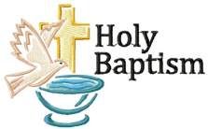
Happy February
Baptismal anniversaries:
Dale Tieman, Rosemarie Kempfer
and Abe Matthews.

Upcoming Events
February 6 – HC Movie Night
February 15 – Friendship Sunday
Playing the bells “Holy, Holy, Holy”


Sunday School Scheduled
to Serve in February:
February 1:
Acolyte: John Mark
Am. Flag: Hannah
Ch Flag: Emily
Greeter: Aubrey
Offering Usher: Matty
Pledge Boards: Megan
Attendance Board: Elizabeth

February 8:
Acolyte: Lynnette
Am. Flag: Emma
Ch Flag: Ella
Greeter: Tad
Offering Usher: Johnna
Pledge Boards: Andrew
Attendance Board: Elijah

February 15:
Acolyte: Bart
Am. Flag: Kamden
Ch Flag: Jacob
Greeter: Bella
Offering Usher: Miriam
Pledge Boards: Craig
Attendance Board: Jaxon

February 22:
Acolyte: Aimee
Am. Flag: Oliver
Ch Flag: Evan
Greeter: Cailyn
Offering Usher: Abigail
Pledge Boards: Linken
Attendance Board: Raylan

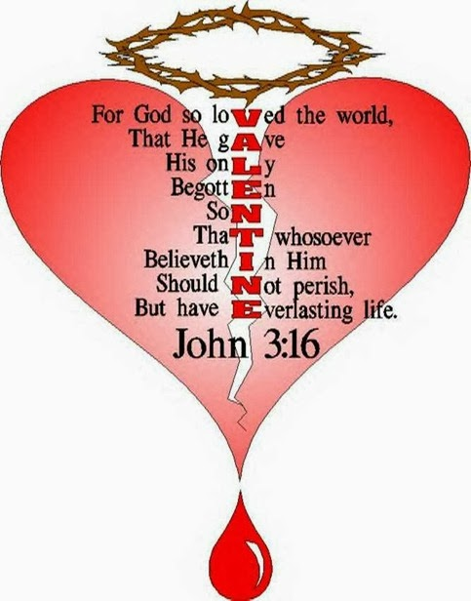


2026 VBS
June 22 - 26
See Brenda Seboldt
if you would like to
teach or help in any way.
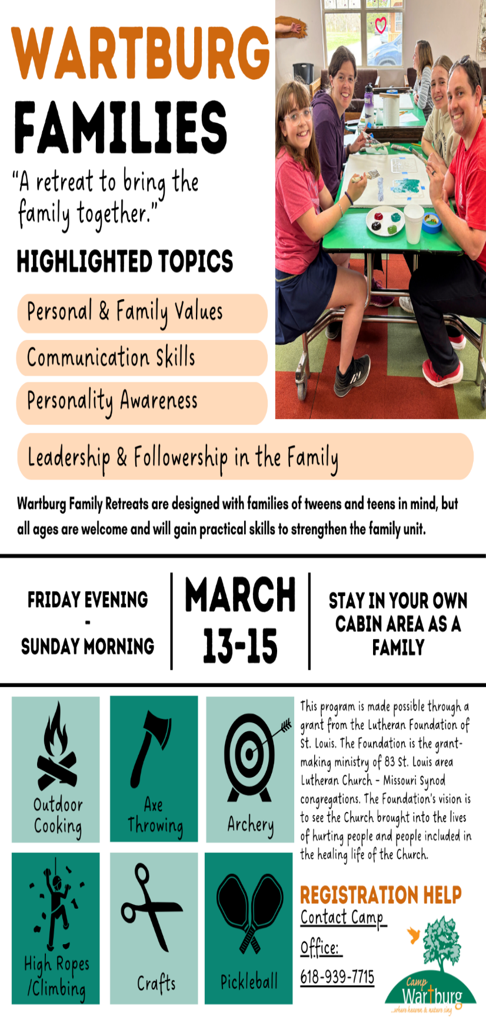
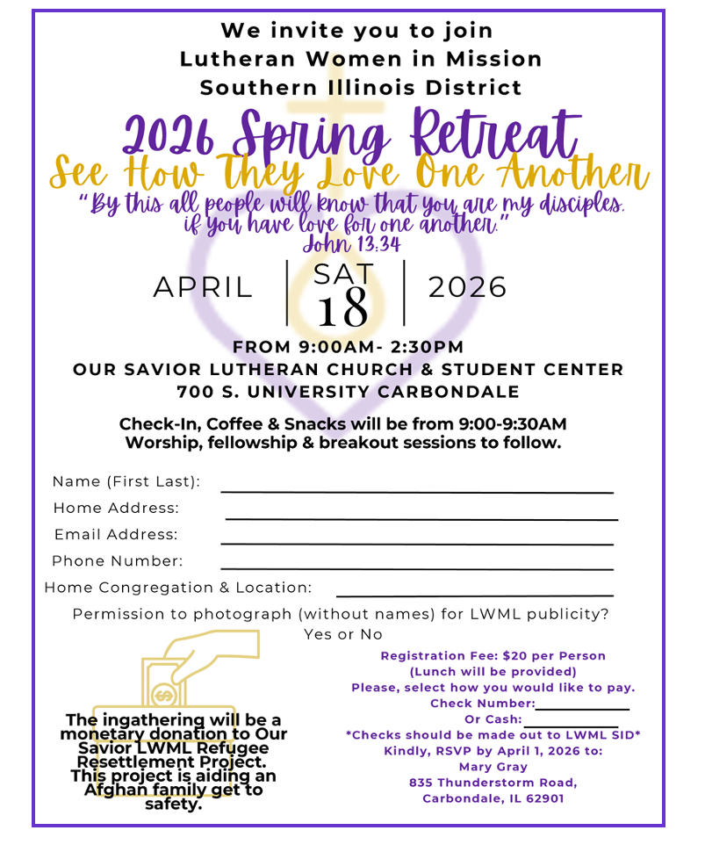


Who doesn't love chocolate? Who doesn't love tea?


Join us on
Sunday, February 15, 2026
from 2:00 p.m. - 4:00 p.m.
for

“A Chocolate Life Tea”

All women of the congregation are invited
and welcome to bring a family member or guests to enjoy our afternoon.

Registration will begin at 1:45 p.m.
Please bring your favorite teacup and saucer to use for the afternoon.

The program will include a Bible Study,
a Chocolate Tasting, Yummy Desserts,
and Fellowship.

Questions?
Ask Linda Keller
Call 618-458-6896 or text 618-340-1957






G ALATIANS 5:22
1 J O HN 4:8
J U D E 21
GALAT I ANS 2:20
ROMAN S 5:8
PSA L M 36:5
J O HN 3:16
PRO V ERBS 10:12
EPH E SIANS 2:4

