  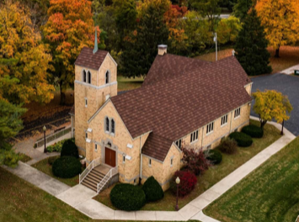      Holy Cross Lutheran Church  2033 Kaskaskia, Renault, IL 62279  618-458-6680  February 15, 2026  Help Share Christ’s Love  With others,  bring a friend  and your family  Email: holycros@htc.net  Facebook: Holy Cross Lutheran Church  Web Page: holycrossrenault.org | 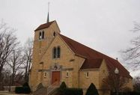  Holy Cross Lutheran Church  2033 Kaskaskia, Renault, IL 62279  618-458-6680  Email: holycros@htc.net  Facebook: Holy Cross Lutheran Church Renault  Web Page: holycrossrenault.org
1853 – “COMFORT, COMFORT YE MY PEOPLE” - 2026
February Calendar of Events 2026 | January Calendar of Events 2022
Sunday | Monday | Tuesday | Wednesday | Thursday | Friday | Saturday
  Ladies Tea Feb 15  2:00 – 4:00 pm | 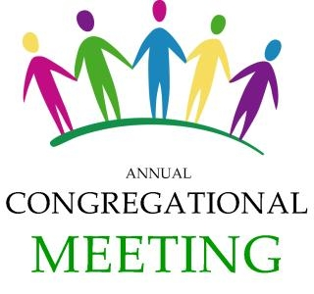 |  |  | 1 | 2 | 3
1  Table Talks 9:00 am Sunday School 9:00 am Worship/Comm Service 10 am  First Service led by Pr. Stefanic | 2  Voters & Congregational    Meeting 7:00 pm | 3 | 4  Confirmation Class 5:00 p  Women’s Bible Study  10:00 am & 7:00 pm  Social Hall | 5 |     6 | 7
 |  |  |  |  | 7pm
8  Table Talks 9:00 am  Sunday School 9:00 am  Worship Service 10:00 am  Council Meeting 11:00 am |   9  Media Committee  Meeting 7 pm | Board of 10    7:00 pm | 11  Confirmation Class 5:00p  SS Teachers &  Bd of Ch Ed.  7:30 pm | 12  Garden Place  9:45 am  Oak Hill 10:30 am  Cedarhurst  11:15 am | 13 |   14
15  Table Talks 9:00 am Sunday School 9:00 am Worship/Comm Service 10 am | 16 | 17 | 18    Confirmation Class 5:00 p | 19 | 20 | 21
Ladies Tea 2 pm |  |   For March Voice | Service 7:00 pm
22  Table Talks 9:00 am  Sunday School 9:00 am  Worship Service 10:00 am | 23 | 24 | 25  Confirmation Class 5:00 p  Lenten Service 7:00 pm | 26 | 27 | 28

