HOLY CROSS LUTHERAN CHURCH
2033 Kaskaskia Rd |  | Renault, Illinois
Sunday School/Table Talks 9:00 a.m. |  | Worship 10:00 a.m.
Rev. James Stefanic, Pastor
Rev. Tyler McMiller, Missionary
Michael Conroy, Seminarian
Office: 618-458-6680 | Email: holycros@htc.net
Website: holycrossrenault.org
Wendy Mueller, Organist | Cailyn Wilson, Acolyte
1853 – “COMFORT, COMFORT YE MY PEOPLE” – 2026
+++++++++++++++++++++++++++++++++++++++++++++++++++++++

FIFTH SUNDAY AFTER THE EPIPANY
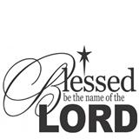
February 8, 2026

Welcome: In the name of the Lord, Jesus Christ, we welcome all our guests and members this morning. Jesus Christ promises us that all who come unto Him will have their burdens lifted. We pray that our guests and members will leave this morning full of the joy imparted by hearing God’s Word. We pray that you will worship with us often.

Our Worship on the Fifth Sunday after the Epiphany:
The Liturgy: ………………... LSB Divine Service Three, p. 184ff
Opening Hymn: …………. LSB #398 Hail to the Lord’s Anointed
Sermon Hymn: ………... LSB #578 Thy Strong Word
Closing Hymn: …….LSB #819 Sing Praise to God, the Highest Good
Old Testament Reading: Isaiah 58:3-9a
Epistle Reading: 1 Corinthians 2:1-12
The Gospel: Matthew 5:13-20

How We Praised the Lord Last Week in The Parish:
Worship Attendance: 89; a year ago, 51
Communed: 66; a year ago, 43
Sunday School: 22; a year ago, 11
Adult Bible Class: 14; a year ago, 8

If you need to reach Pastor Stefanic, his personal email is jjstefanic15@gmail.com or phone # 414-305-8565.
At Work and Worship This Week in The Parish:
Today: Council Meeting ………………………….. 11:00 a.m.
Monday: Media Committee Meeting …………...…… 7:00 p.m.
Tuesday: Pastor @ Winkel, Freeburg………………… 9:00 a.m.
Bd of Comm. Outreach ………………..…... 7:00 p.m.
Wednesday: Confirmation Class 5:00 p.m.
SS Teachers & Bd of Ch. Ed. ……………… 7:30 p.m.
Thursday: Garden Place, Oak Hill & Cedarhurst
Sunday: Sunday School & Table Talks 9:00 a.m.
Worship Service/Friendship Sunday 10:00 a.m.
Ladies Tea …………………………….…… 2:00 p.m.

Birthdays This Week in The Parish:
February 8 – Timothy Dougherty
8 – Betty Gross
9 – Steve Sickmeier
9 – Jessa Johanning
9 – Lilah Johanning
12 – Maverick Veach

Spiritual Discipline (February): Daily Read at least one chapter of the Bible.
Hymn of the Month (February): LSB #656 “A Mighty Fortress Is Our God”

In Our Prayers: Mark Ottoson; Rev. Royal Boeder; Mark Wilson; Johanna Dougherty; Larry Matzenbacher; Kathy Baker; Jim Keller; Glen Meyer; Joe Whelan; Ella Guebert.
Rich in years members: Mary Veach; Anita Mueller; Laverne Hinrichs; Virginia Strong; Roger Johnson; Wilma Heller; Marlene Deterding; Roger Toenjes.
friends and family of members: Jonah Cooksey; Jo Ann Candler; Andrea Kuehner; Dave Moore; Floyd Higgerson; Rosemary Schultheis; Riley Foster; Kenneth Kelley; Ashley Schrader; Randy Wetzler; Evelyn Marquardt; Doris Wilson; Allison Ford; Zachary Glenn; Carolyn Henry; Janine Drury; Troy Biernbaum.
Members, family, and friends in the military: John Michael Glossip; Brett Biernbaum; Luke Crider; Gage Baldwin; Madelyn Brown; Stephen Beaulieu; Cameron Hill; Cameron Jackson.

Serving on Sunday February 15 & 18:
Elder: Mark Seboldt (15th only)
Head Usher: Jim Seboldt
Ushers: Mark Ottoson, Tim Dougherty
Donald Schultheis, Kyle Guebert
Acolyte: Aubrey Melching (15th only)
Counters: Kenny & Sandy Schultheis
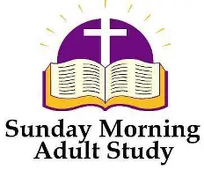
Table Talks: Join us each Sunday morning at 9am for a Bible Study on the book of Exodus. Today we wrap up Exodus 1 and begin a study of chapter 2

Sunday School: In Christian education this week, we learn how “Fishers Follow.” Spotting some fishing boats by the shore of Galilee, Jesus turns Simon Peter’s boat into a floating pulpit. He preaches from the boat and then commands the disciples to put out to fish. Although they had fished all night without a catch, now they find their nets full to bursting. Recognizing his sinfulness, Peter falls down in front of his Savior and Lord, who calls him to a new kind of fishing. Ask, “How does God help us recognize our sinfulness? How does He rescue us from our sins?”

Communion Registration: Holy Communion will be celebrated next Sunday. If you wish to register your intention to partake, please fill out a registration card. Please place it in the offering basket or on the usher’s table at the back of church. Cards may be found in the record sheets folders or on the usher’s table.

2026 VBS
June 22 - 26
See Brenda Seboldt
if you would like to
teach or help in any way.

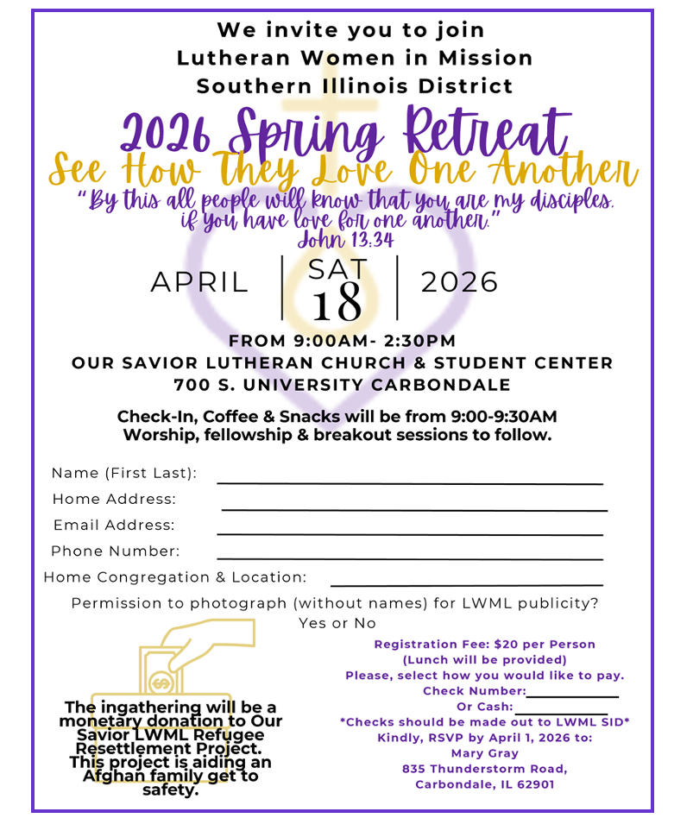



2026 Calendar of Upcoming Events:
Feb 8: Council Meeting 11:00 am
Feb 9: Media Committee 7:00 pm
Feb 10: Bd of Community Outreach 7:00 pm
Feb 11: Confirmation Class 5:00 pm
Feb 11: SS Teachers & Bd of Ch. Ed 7:30 pm
Feb 12: Garden Place, Oak Hill, Cedarhurst
Feb 15: Friendship Sunday
Feb 15: Ladies “A Chocolate Life Tea” 2 pm – 4 pm
Feb 17: March Voice Deadline
Feb 18: Confirmation Class 5:00 pm
Feb 18: Ash Wednesday Service 7:00 pm
Feb 25: Confirmation Class 5pm /Lenten Service 7pm
Mar 4: Confirmation Class 5pm /Lenten Service 7pm
Mar 4: Elders’ Meeting 8:15 pm
Mar 8: Council Meeting 11:00 am
Mar 8: All You Can Eat Chicken Dinner St John Baldwin
Mar 11: Confirmation Class 5pm /Lenten Service 7pm
Mar 13: Wartburg Family Weekend
Mar 18: Confirmation Class 5:00 pm
Mar 18: Lenten Service 7:00 pm
Mar 20: April Voice Deadline
Mar 25: Confirmation Class 5:00 pm
Mar 25: Lenten Service 7:00 pm
Mar 29: Palm/Confirmation Sunday 10:00 am
Apr 2: Maundy Thursday 7:00 pm
Apr 3: Good Friday 7:00 pm
Apr 4: LYF Set up for Easter Breakfast
Apr 5: Easter 6:30 & 10:00 am
Apr 14: Council Meeting 7:00 pm
Apr 18: LWML Spring Retreat
Apr 21: May Voice Deadline
Apr 26: Trivia Event for Holy Cross Family
Apr 27: Voters’ Meeting 7:00 pm
Jun 22 – 26: VBS Week



Media Committee
Sunday, February 8 Monday, February 9
11:00 am 7:00 pm


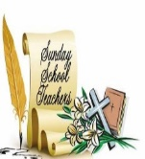

Board of
&

Wednesday, February 11
Tuesday, February 10 7:30 pm
7:00 pm




The program will include a
Bible Study, a Chocolate Tasting,
Yummy Desserts, and Fellowship.

Holy Cross Friendship Sunday
February 15, 2026
As members of Christ, we should always keep in mind to invite people to come worship with us. The Board of Community Outreach would like to see aside February 15 as Friendship Sunday where we encourage all our members to invite a friend to worship with us that day.

Looking forward to seeing new faces
worshiping with us that day!


Who doesn't love chocolate? Who doesn't love tea?



Join us on
Sunday, February 15, 2026
from 2:00 p.m. - 4:00 p.m.
for

“A Chocolate Life Tea”

All women of the congregation are invited
and welcome to bring a family member or guests to enjoy our afternoon.

Registration will begin at 1:45 p.m.
Please bring your favorite teacup and saucer to use for the afternoon.

Questions?
Ask Linda Keller
Call 618-458-6896 or text 618-340-1957

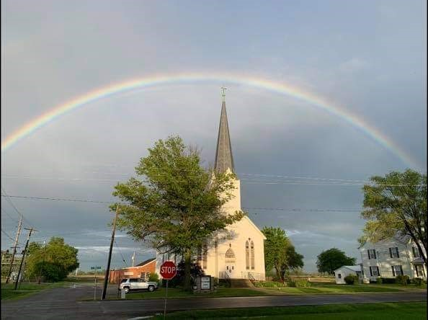

ST. JOHN’S LUTHERAN CHURCH
BALDWIN, IL

All-You-Can-Eat Chicken Dinner
(dine-in only)

March 8, 2026
Serving from 10:30 a.m. – 1:30 p.m.
Carry Outs Available
(1/2 chicken only with sides)

Menu:
Fried Chicken, Mashed Potatoes-Gravy, Corn,
Green Beans, Slaw, Homemade Desserts,
Tea, Lemonade, Coffee

Prices:
Adults - $16 Children - $8 Under 4 – Free


Proceeds to support Lutheran Schools in Red Bud, Prairie, Steeleville and Chester

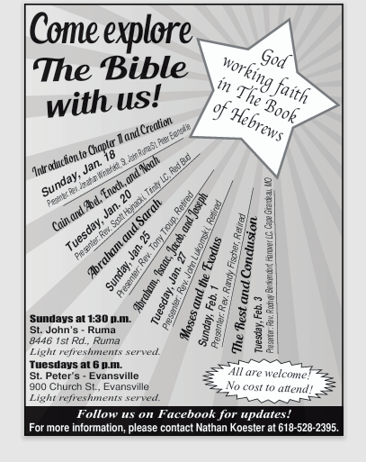

Due to the extreme winter weather, the Bible Presentations were canceled for Sunday, January 25, and Tuesday, January 27. These presentations will be rescheduled as follows: Pastor Anthony Troup will present on Sunday, February 8, at St. John's Lutheran, Ruma, at 1:30 pm and Pastor John Lukomski will present on Tuesday, February 10, at St. Peter's Lutheran, Evansville, at 6pm. We hope to see you there!
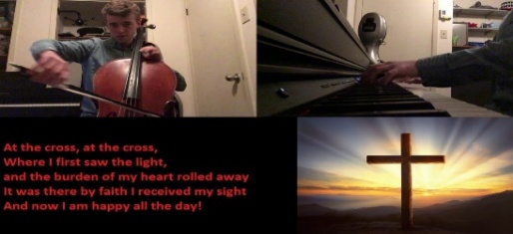

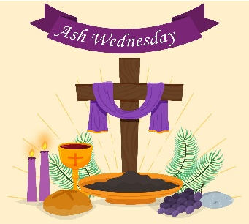

ASH WEDNESDAY
FEBRUARY 18 AT 7:00 P.M.
Holy Communion
============================================



“From Depths of Woe:

Redemption of the Patriarchs”

Midweek Lenten Services: 2026

  - Holy Cross Lutheran Church - Renault, Illinois

WEDNESDAY AFTER THE FIRST SUNDAY IN LENT
February 25 AT 7:00 P.M.

  - “The Redemption of Our Worship”

  - ============================================
WEDNESDAY AFTER THE SECOND SUNDAY IN LENT
MARCH 4 AT 7:00 P.M.
  - “The Redemption of Our Brotherhood”


  - ============================================
WEDNESDAY AFTER THE THIRD SUNDAY IN LENT
MARCH 11 AT 7:00 P.M.
  - “The Redemption of Our Witness”
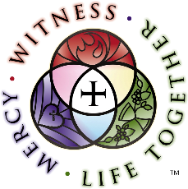

  - ============================================
WEDNESDAY AFTER THE FOURTH SUNDAY IN LENT
MARCH 18 AT 7:00 P.M.

  - “The Redemption of Our Rest”

  - ============================================
WEDNESDAY AFTER THE FIFTH SUNDAY IN LENT
MARCH 25 AT 7:00 P.M.
  - “Rebuilding of the House of God”




  - ============================================

