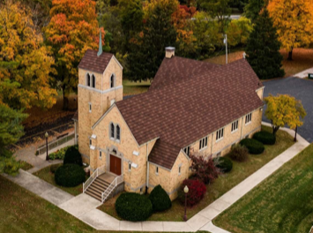        Holy Cross Lutheran Church  2033 Kaskaskia, Renault, IL 62279  618-458-6680  Email: holycros@htc.net  Facebook: Holy Cross Lutheran Church  Installation of newly- elected officers & board members on January 4, 2026  Web Page: holycrossrenault.org | 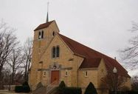  Holy Cross Lutheran Church  2033 Kaskaskia, Renault, IL 62279  618-458-6680  Email: holycros@htc.net  Facebook: Holy Cross Lutheran Church Renault  Web Page: holycrossrenault.org
1853 – “COMFORT, COMFORT YE MY PEOPLE” - 2026
January Calendar of Events 2026 | January Calendar of Events 2022
Sunday | Monday | Tuesday | Wednesday | Thursday | Friday | Saturday
Council Meeting Jan 14  at 7:00 pm  Voters/ Congregational Meeting Jan 26  7:00 pm | 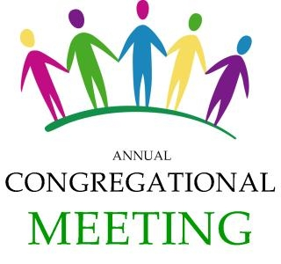 |  |  |   1 | 2 | 3
4  Table Talks 9:00 am Sunday School 9:00 am Worship/Comm Service 10 am Decorations put away after worship service | 5 | 6  Women’s Bible Study  10:00 am & 7:00 pm  Social Hall | 7  Confirmation Class 5:00 p    for  Stefanic  family | 8 | 9 |   10  2:00 pm – 4:00 pm  & meet the Stefanic  family
11  Table Talks 9:00 am  Sunday School 9:00 am  Worship Service 10:00 am | 12 | 13  Council Meeting  7:00 pm upstairs  In the Social Hall | 14  Confirmation Class 5:00p  SS Teachers &  Bd of Ch Ed.  7:30 pm | 15 | 16 | 17
18  Table Talks 9:00 am Sunday School 9:00 am Worship/Comm Service 10 am | 19 | 20 | 21    Confirmation Class 5:00 p | 22 | 23 | 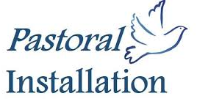  24
 |  |  | for February  Voice |  |  | 3:00 pm  Rev. James Stefanic
25  Table Talks 9:00 am  Sunday School 9:00 am  Worship Service 10:00 am  First Service led by Pr. Stefanic | 26  Voters & Congregational  Meeting  7:00 pm | 27 | 28  Confirmation Class 5:00 p | 29 | 30 |   31

